教材 | Dino on the Go (7) | 教師 | Angela Wu (吳淑娟)
班級 | 601 | 班級人數 | 22
教學時間 | 40 分鐘 | 日期 | 10/21/2022
觀課時間 | 第三節 (10:30-11:00)
主題: Review 1
*Unit 1 : Where are you from?
*Unit 2: How Do You Go to School?
教學目標
- 複習Unit 1-Unit2 主要句型與單字
Unt 1:
單字: Australia, India, Japan, Singapore, Spain, Taiwan, the UK, the USA
補充單字: America, Koreae, China, Italy, country
句型: Where (are) (you) from? (I'm) from (Taiwan).
(Are) you from (Taiwan)? Yes, (I) (am). No, (I'm) not.
Phonics: ar, er, or

Unit 2:
單字: by bike, by boat, by bus, by car, by MRT, by metro, by plane, by scooter, by taxi, by train, school
句型: How (do) (you) go to (school)? (I) (go) to (school) (by car).
(Do) you go to (school) (by bus)? Yes, (I) (do). No, (I) (don't)
2) Phonics: ir, ur, 並複習Starter-Unit 1 er, ar, or
3) Review 1: 課文
熟讀並理解課本p.32 課文內容
4)以遊戲方式取代寫測驗練習卷方式，為即將到來的期中考做準備。
學生經驗
已經做過Unit 1-2 單字、句型紙筆測驗、Unit 1 習作測驗 (Unit 2 習作測驗未實施)

教學流程及活動設計 |  |  |  | 時間
(課前抄寫下週測驗進度)  活動一: Phonics Time: ir, ur & review ar, er, or (p.28-29)  1) 唸讀p. 28 Phonics Time & p.29 Phonics Story  2) 複習ar, or, er  3) 唸讀 p. 34  3) Game: Hear & Say  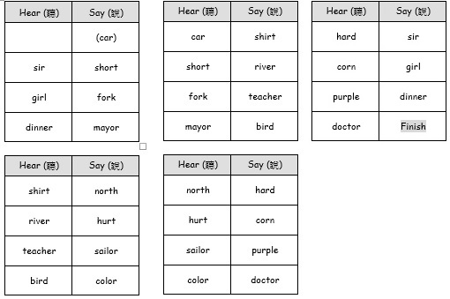第一階段: 各組比賽 (5人一組，共分四組~異質分組)  第二階段: 男女PK賽 (男女各選最優5人PK賽) |  |  |  | 15
活動二:  以Wordwall 複習Unit 1 & Unit 2 句型 |  |  |  | 5’
活動二: 唸讀並理解 Review 1 p.32 課文  1) 播放電子書 p.32  2) 學生唸讀 p.32  3) Q/A: 聽力理解與口說練習  4) Game: Let's Kahoot! |  |  |  | 20’

