**Andriod系統與新興科技111**

**一、什麼是Android(安卓)系統:**

**由Google成立的Open Handset Alliance(開放手機聯盟)領導與開發的行動作業系統，於2003年10月由**[安迪·魯賓](https://www.google.com/url?q=https%3A%2F%2Fzh.wikipedia.org%2Fwiki%2F%25E5%25AE%2589%25E8%25BF%25AA%25C2%25B7%25E9%25B2%2581%25E5%25AE%25BE&sa=D&sntz=1&usg=AOvVaw3nOlh6rQRwPtAhPal8-HdJ)、[利奇·米納爾](https://www.google.com/url?q=https%3A%2F%2Fzh.wikipedia.org%2Fw%2Findex.php%3Ftitle%3D%25E5%2588%25A9%25E5%25A5%2587%25C2%25B7%25E7%25B1%25B3%25E7%25BA%25B3%25E5%25B0%2594%26action%3Dedit%26redlink%3D1&sa=D&sntz=1&usg=AOvVaw0M5V3QhT-9PhtSvH1EbcQD)、[尼克·席爾斯](https://www.google.com/url?q=https%3A%2F%2Fzh.wikipedia.org%2Fw%2Findex.php%3Ftitle%3D%25E5%25B0%25BC%25E5%2585%258B%25C2%25B7%25E5%25B8%25AD%25E7%2588%25BE%25E6%2596%25AF%26action%3Dedit%26redlink%3D1&sa=D&sntz=1&usg=AOvVaw2FWbS5kwz-NP4jv3ldVnSS)、[克里斯·懷特](https://www.google.com/url?q=https%3A%2F%2Fzh.wikipedia.org%2Fwiki%2F%25E5%2585%258B%25E9%2587%258C%25E6%2596%25AF%25C2%25B7%25E6%2587%25B7%25E7%2589%25B9&sa=D&sntz=1&usg=AOvVaw21CNyDfmKl9Hj5B5Ed3FDR)**等人在加州帕羅奧圖建立。**

**Android系統普及，是因為Google以 免費開放原始碼 許可證的授權方式(內核為Linux)，發布了Android系統的原始碼，讓手機的生產商加以運用，推出搭載此系統的智慧型手機，隨後更擴大使用範圍，將版圖拓展到平板電腦及其他領域上。**

**它開放原始碼，讓一般人也可以輕易的利用 SDK ( Software Development Kit ) 開發各式各樣的軟體(如:AI2 APPinventor)，另外也結合了各項 Google 所提供的服務功能，使得 Android 作業系統在短短的幾年內迅速成竄起。**



2008年9月22日，**台灣宏達電HTC**為美國運營商德國T-Mobile代工，製造第一款Android手機—**T-Mobile G1**

**資料來源:**[**https://zh.wikipedia.org/wiki/Android**](https://www.google.com/url?q=https%3A%2F%2Fzh.wikipedia.org%2Fwiki%2FAndroid&sa=D&sntz=1&usg=AOvVaw308RpErs1NQKTxbjBS9eIp)

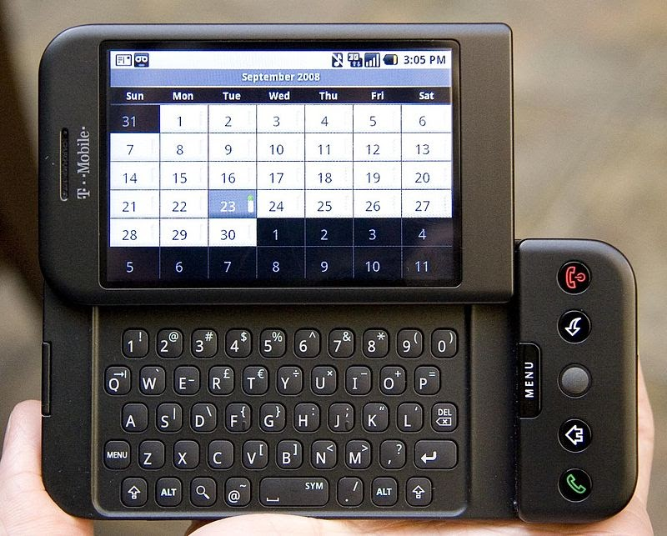

**二、行動裝置的新興科技:**

**(一)智慧型手錶:**

**智慧型手錶可以隨時量測個人的步行數量、睡眠品質、心率及運動狀態等，有些還能偵測氣壓、進行 GPS 定位、發送訊息、播放音樂等。**

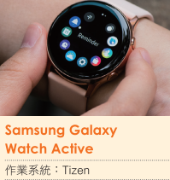

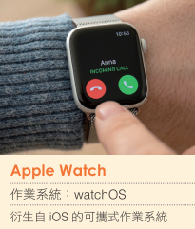

**(二)智慧型眼鏡:**

**Google眼鏡，具備人工智慧引擎，可以進行識物學習、判斷和動作預測等功能。**

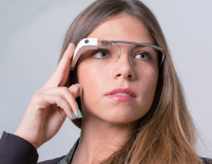

**此眼鏡是針對企業和開發者設計的產品，主要用於建築、醫療輔助等用途。**

**(三)NFC技術: (樂學卡)**

**近距離無線通訊**（Near-field communication，NFC），又簡稱**近距離通訊**或**近場通訊**，是一套[通訊協定](https://www.google.com/url?q=https%3A%2F%2Fzh.wikipedia.org%2Fwiki%2F%25E9%2580%259A%25E8%25A8%258A%25E5%258D%2594%25E5%25AE%259A&sa=D&sntz=1&usg=AOvVaw0IORF0GIiZdLSKcD0beWK_)，讓兩個電子裝置（其中一個通常是行動裝置，例如[智慧型手機](https://www.google.com/url?q=https%3A%2F%2Fzh.wikipedia.org%2Fwiki%2F%25E6%2599%25BA%25E6%2585%25A7%25E5%259E%258B%25E6%2589%258B%25E6%25A9%259F&sa=D&sntz=1&usg=AOvVaw2FNTMw6FMqzYOjqRIloSAE)）在相距幾公分之內進行[通訊](https://www.google.com/url?q=https%3A%2F%2Fzh.wikipedia.org%2Fwiki%2F%25E8%25B3%2587%25E6%2596%2599%25E5%2582%25B3%25E8%25BC%25B8&sa=D&sntz=1&usg=AOvVaw1TXy_gwWCEmHA0iuLoxlu-)。

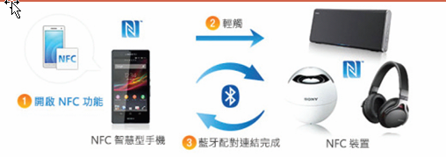

NFC，如同過去的[電子票券](https://www.google.com/url?q=https%3A%2F%2Fzh.wikipedia.org%2Fw%2Findex.php%3Ftitle%3D%25E9%259B%25BB%25E5%25AD%2590%25E7%25A5%25A8%25E5%2588%25B8%26action%3Dedit%26redlink%3D1&sa=D&sntz=1&usg=AOvVaw1ARfc54-NidE1okZLBdJ8V)智慧卡一般，將允許[**行動支付**](https://www.google.com/url?q=https%3A%2F%2Fzh.wikipedia.org%2Fwiki%2F%25E8%25A1%258C%25E5%258B%2595%25E6%2594%25AF%25E4%25BB%2598&sa=D&sntz=1&usg=AOvVaw3lTkw5lhf8ltJawpkXNGmp)取代或支援這類系統。NFC應用於[社群網路](https://www.google.com/url?q=https%3A%2F%2Fzh.wikipedia.org%2Fwiki%2F%25E7%25A4%25BE%25E7%25BE%25A4%25E7%25B6%25B2%25E8%25B7%25AF%25E6%259C%258D%25E5%258B%2599&sa=D&sntz=1&usg=AOvVaw1c-i84IK8NyLLp3gDQPkE4)，分享聯絡方式、相片、影片或檔案。具備 **NFC 功能的裝置可以充當電子**[**身分證**](https://www.google.com/url?q=https%3A%2F%2Fzh.wikipedia.org%2Fwiki%2F%25E8%25BA%25AB%25E5%2588%2586%25E8%25AD%2589&sa=D&sntz=1&usg=AOvVaw0GyVMlxh3BLaa1A42VF9l3)**和**[**鑰匙卡**](https://www.google.com/url?q=https%3A%2F%2Fzh.wikipedia.org%2Fw%2Findex.php%3Ftitle%3D%25E9%2591%25B0%25E5%258C%2599%25E5%258D%25A1%25E9%258E%2596%26action%3Dedit%26redlink%3D1&sa=D&sntz=1&usg=AOvVaw2CMS6cY9rW3j-BkVlCeSmS)。NFC 提供了設定簡便的低速連接，也可用於引導能力更強的無線連接。

**資料來源:**[**https://zh.wikipedia.org/wiki/近場通訊**](https://www.google.com/url?q=https%3A%2F%2Fzh.wikipedia.org%2Fwiki%2F%E8%BF%91%E5%A0%B4%E9%80%9A%E8%A8%8A&sa=D&sntz=1&usg=AOvVaw1Oh1hoGEO_6nH_vmAc6vJC)



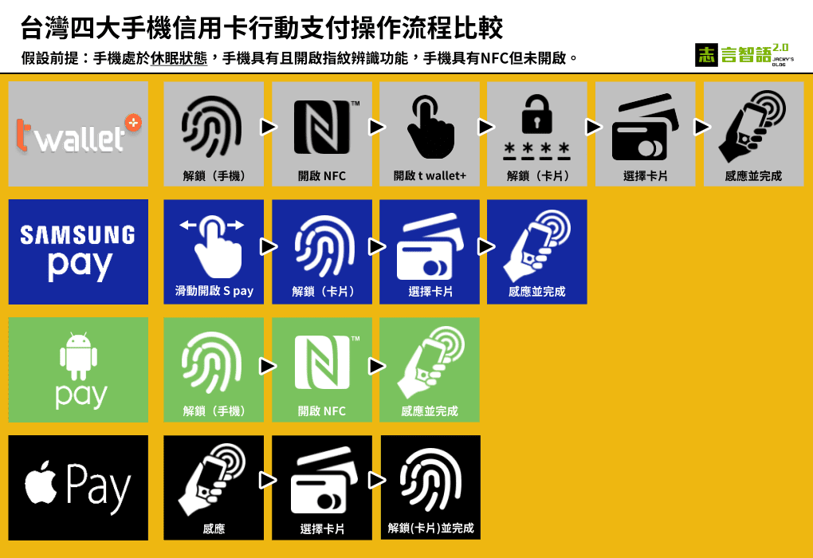

**(四)二維條碼QR Code:**

**QR-CODE 比普通一維條碼具有快速讀取和更大的儲存資料容量，也無需要像一維條碼般在掃描時需要直線對準掃描器。因此其應用範圍已經擴展到包括產品跟蹤，物品識別，文件管理，庫存營銷等方面。**

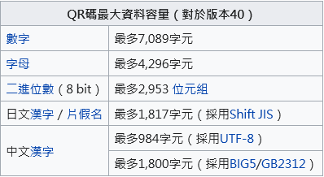



↑ **傳統一維碼**

**二維碼↓**



**QR碼有容錯能力，QR碼圖形如果有破損，仍然可以被機器讀取內容，最高可以到30%面積破損仍可被讀取。所以QR碼可以被廣泛使用在運輸外箱上。 相對而言，容錯率愈高，QR碼圖形面積愈大。所以一般折衷使用15%容錯能力。**

**資料來源:** [**https://zh.wikipedia.org/wiki/QR%E7%A2%BC**](https://www.google.com/url?q=https%3A%2F%2Fzh.wikipedia.org%2Fwiki%2FQR%25E7%25A2%25BC&sa=D&sntz=1&usg=AOvVaw2RhqTUouCwZQo5nraqxpXe)

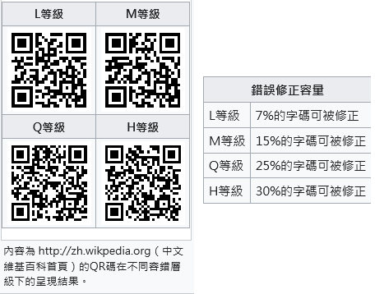

**(五)VR/AR/MR:**

[**「虛擬實境」**](https://www.google.com/url?q=https%3A%2F%2Fwww.inside.com.tw%2Farticle%2F6633-what-is-vr-ar-mr&sa=D&sntz=1&usg=AOvVaw2geKOPdEMOQsinAu_tGlmb) **(Virtual Reality, VR)** :利用電腦技術模擬出一個立體、高擬真的 3D 空間，當使用者穿戴特殊顯示裝置 (VR 眼鏡) 進入後，會 **產生好像處在現實中一般的錯覺**。在這空間中，操作者可以藉由控制器或鍵盤在這個虛擬的環境下穿梭或互動!

**「**[**擴增實境**](https://www.google.com/url?q=https%3A%2F%2Fwww.inside.com.tw%2Farticle%2F6633-what-is-vr-ar-mr&sa=D&sntz=1&usg=AOvVaw2geKOPdEMOQsinAu_tGlmb) **( Augmented Reality, AR)」** :一種將虛擬資訊擴增到現實空間中的技術， **它不是要取代現實空間，而是在現實空間中添加一個虛擬物件** ，藉由攝影機的辨識技術與電腦程式的結合，當設定好的圖片出現在鏡頭裡面，就會出現對應的虛擬物件。

[**「混合實境」**](https://www.google.com/url?q=https%3A%2F%2Fwww.inside.com.tw%2Farticle%2F6633-what-is-vr-ar-mr&sa=D&sntz=1&usg=AOvVaw2geKOPdEMOQsinAu_tGlmb) **(Mixed Reality,MR)** : 把**現實世界與虛擬世界合併在一起**，從而建立出一個新的環境以及符合一般視覺上所認知的虛擬影像，在這之中現實世界中的物件能夠與數位世界中的物件共同存在並且即時的產生互動。

**Andriod新興科技操作活動111**

**一、QR-CODE線上製作:**

**操作說明：**

**(一) 先上** [**https://qr.ioi.tw/zh/**](https://www.google.com/url?q=https%3A%2F%2Fqr.ioi.tw%2Fzh%2F&sa=D&sntz=1&usg=AOvVaw2ky3uHeoUsH3a02tGMyg5H) **線上製作網站**

**(二) 製作說明:**

**1.QR碼內容輸入: 請選擇 網址**

**2.網址部分待今日作品完成後，再填入。**

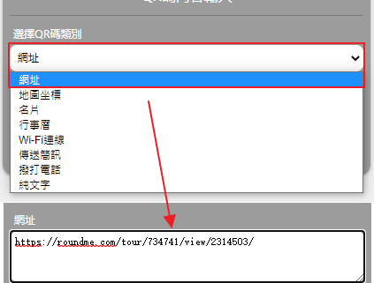

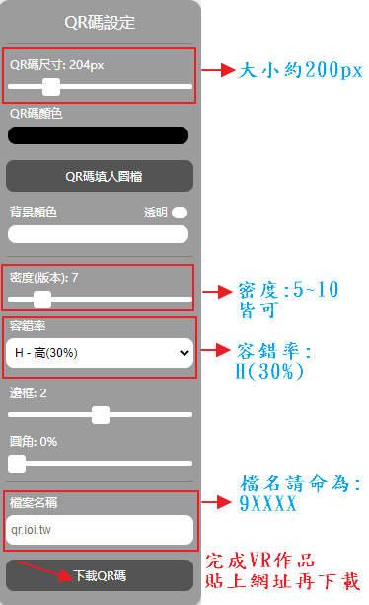

**(三) 可調整大小、顏色、容錯率:**

**1.QR碼尺寸: 約200px**

**2.密度: 大約 5~10 內皆可。**

**3.容錯率: H (高 30% )**

**4.檔案名稱: 9XXXX**

**5.先不下載QR-CODE**

* **其他顏色、背景、邊框...等，可自行調整**

**(三) 可調整大小、顏色、容錯率:**

**1.選擇LOGO模式: 文字-方塊**

**2.文字:填入 9xxxxOOO (班級姓名)**

**3.尺寸大小: 10% (不遮住QR-CODE)**

* **其他字體顏色、字型、位置...等，可自行調整**

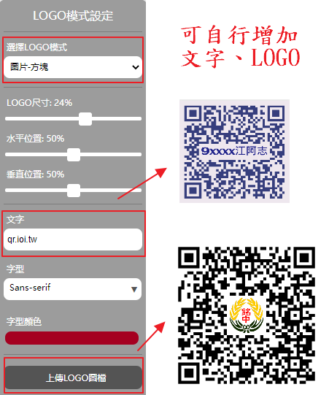

**二、VR 虛擬實境線上製作:**

**操作說明：**

**(一) 先下載老師所提供之360圖片**

**1.**[**海科館圖片下載**](https://drive.google.com/drive/folders/133WDIIqdOO0i4oJG6PD9sG_YwjD7zO9W?usp=sharing)**、**[**海科館介紹**](https://www.google.com/url?q=https%3A%2F%2Fzh.m.wikipedia.org%2Fwiki%2F%25E5%259C%258B%25E7%25AB%258B%25E6%25B5%25B7%25E6%25B4%258B%25E7%25A7%2591%25E6%258A%2580%25E5%258D%259A%25E7%2589%25A9%25E9%25A4%25A8&sa=D&sntz=1&usg=AOvVaw1wOfZYp9d5t_wUlu3jcUnd) **2.**[**野柳圖片下載**](https://drive.google.com/drive/folders/13-5-l2xLRAogEg11ghTKMfXauGQDI38_?usp=sharing)**、**[**野柳介紹**](https://www.google.com/url?q=https%3A%2F%2Fzh.m.wikipedia.org%2Fwiki%2F%25E9%2587%258E%25E6%259F%25B3%25E9%25A2%25A8%25E6%2599%25AF%25E7%2589%25B9%25E5%25AE%259A%25E5%258D%2580&sa=D&sntz=1&usg=AOvVaw048G_DVgUD6wIYESzWsJHP)  
**3.**[**台北故宮圖片下載**](https://drive.google.com/drive/folders/131oNWVjFAOmW9O4fRdV2JoCsbIacFnZe?usp=sharing)**、**[**台北故宮介紹**](https://www.google.com/url?q=https%3A%2F%2Fzh.m.wikipedia.org%2Fwiki%2F%25E5%259C%258B%25E7%25AB%258B%25E6%2595%2585%25E5%25AE%25AE%25E5%258D%259A%25E7%2589%25A9%25E9%2599%25A2&sa=D&sntz=1&usg=AOvVaw18m72a3H8UHGreALkpubYj) **4.**[**東京鐵塔圖片下載**](https://drive.google.com/drive/folders/12h8fM1X-rRjA3eGztkrqrovz8Qr6Xnph?usp=sharing)**、**[**東京鐵塔介紹**](https://www.google.com/url?q=https%3A%2F%2Fzh.m.wikipedia.org%2Fwiki%2F%25E4%25B8%259C%25E4%25BA%25AC%25E9%2593%2581%25E5%25A1%2594&sa=D&sntz=1&usg=AOvVaw03AGLrsk0SrxVNj5uqjftI)  
**5.**[**巴黎凱旋門圖片下載**](https://drive.google.com/drive/folders/139lzC6P6xWCx_v1nWxeqNKhxOQearYM7?usp=sharing)**、**[**凱旋門介紹**](https://www.google.com/url?q=https%3A%2F%2Fzh.m.wikipedia.org%2Fwiki%2F%25E5%25B7%25B4%25E9%25BB%258E%25E5%2587%25AF%25E6%2597%258B%25E9%2597%25A8&sa=D&sntz=1&usg=AOvVaw24FXbX8VsxmYpuCs5vcZBu) **6.**[**法國羅浮宮圖片下載**](https://drive.google.com/drive/folders/13CGKjnQCQsev_DoEeTX2Z5D1YZcIpPCW?usp=sharing)**、**[**羅浮宮介紹**](https://www.google.com/url?q=https%3A%2F%2Fzh.m.wikipedia.org%2Fwiki%2F%25E5%258D%25A2%25E6%25B5%25AE%25E5%25AE%25AB&sa=D&sntz=1&usg=AOvVaw0nGnJIw6pBjTGieCSe7rpZ)

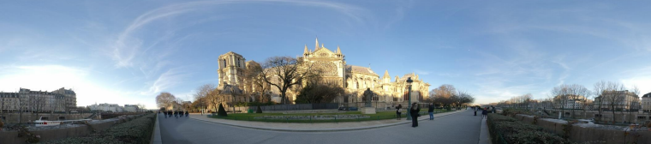

三維 立體感 360度全景圖



一般二維 360度全景圖

**↓↓↓↓↓以下供參↓↓↓↓↓**

**1.使用**[**Street View Download 360**](https://www.google.com/url?q=https%3A%2F%2Fsvd360.istreetview.com%2F&sa=D&sntz=1&usg=AOvVaw3PnukXsV3ajlh4jmq8ch7p) **軟體   
(Google街景下載)**

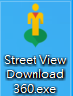

**2. 至 GoogleMap 找一個你想知道的地點介紹(如:**[**海科館**](https://www.google.com.tw/maps/place/%E5%9C%8B%E7%AB%8B%E6%B5%B7%E6%B4%8B%E7%A7%91%E6%8A%80%E5%8D%9A%E7%89%A9%E9%A4%A8/@25.1403317,121.7975102,3a,75y,119.44h,105.31t/data=!3m8!1e1!3m6!1sAF1QipOscEXMcz-zNZlmz02vaxg_Yrtng_FH7Oqqtot-!2e10!3e11!6shttps:%2F%2Flh5.googleusercontent.com%2Fp%2FAF1QipOscEXMcz-zNZlmz02vaxg_Yrtng_FH7Oqqtot-%3Dw203-h100-k-no-pi-15.305468-ya212.23634-ro0-fo100!7i13312!8i6656!4m11!1m2!2m1!1z5rW356eR6aSo!3m7!1s0x345d4f7807d7ab5d:0xe005c55719594f84!8m2!3d25.1400236!4d121.7985672!14m1!1BCgIgARICCAI!15sCgnmtbfnp5HppKiSARF0ZWNobm9sb2d5X211c2V1bQ)**、**[**潮境公園**](https://www.google.com.tw/maps/place/%E6%BD%AE%E5%A2%83%E5%85%AC%E5%9C%92/@25.1469634,121.8070192,3a,75y,180h,90t/data=!3m8!1e1!3m6!1sAF1QipMb7ZON5Tj0xrPbVyyRniN_mzGJrZNpXKE-_pYI!2e10!3e11!6shttps:%2F%2Flh5.googleusercontent.com%2Fp%2FAF1QipMb7ZON5Tj0xrPbVyyRniN_mzGJrZNpXKE-_pYI%3Dw203-h100-k-no-pi-1.7136685-ya261.81982-ro13.091746-fo100!7i5376!8i2688!4m11!1m2!2m1!1z5r2u5aKD5YWs5ZyS!3m7!1s0x345d4f796bf63419:0x933818b7df70488e!8m2!3d25.1434517!4d121.8034149!14m1!1BCgIgARICCAI!15sCgzmva7looPlhazlnJKSAQRwYXJr)**、**[**野柳**](https://www.google.com.tw/maps/place/%E9%87%8E%E6%9F%B3%E5%9C%B0%E8%B3%AA%E5%85%AC%E5%9C%92Yehliu+Geopark/@25.2063972,121.6904658,3a,75y,160h,110t/data=!3m8!1e1!3m6!1sAF1QipMcBeG-u96NA6IHpPPX1E_1h01OwH6K7JxYwR7w!2e10!3e11!6shttps:%2F%2Flh5.googleusercontent.com%2Fp%2FAF1QipMcBeG-u96NA6IHpPPX1E_1h01OwH6K7JxYwR7w%3Dw203-h100-k-no-pi-20-ya160-ro-0-fo100!7i7200!8i3600!4m7!3m6!1s0x345d4c760ae69ad5:0xe4d117305ac26857!8m2!3d25.2063972!4d121.6904658!14m1!1BCgIgARICCAI)**、**[**科博館**](https://www.google.com.tw/maps/place/%E5%9C%8B%E7%AB%8B%E8%87%AA%E7%84%B6%E7%A7%91%E5%AD%B8%E5%8D%9A%E7%89%A9%E9%A4%A8/@24.1572335,120.6660606,3a,75y,20h,90t/data=!3m8!1e1!3m6!1sAF1QipMoPLja_TgZ4y0uplE_i8CUlgWHo7uMvVS24E6C!2e10!3e11!6shttps:%2F%2Flh5.googleusercontent.com%2Fp%2FAF1QipMoPLja_TgZ4y0uplE_i8CUlgWHo7uMvVS24E6C%3Dw203-h100-k-no-pi0-ya20-ro0-fo100!7i5656!8i2828!4m7!3m6!1s0x34693d78069134cb:0xf7a65bba8f974f36!8m2!3d24.1572335!4d120.6660606!14m1!1BCgIgARICCAI)**、**[**故宮博物院**](https://www.google.com.tw/maps/place/%E5%9C%8B%E7%AB%8B%E6%95%85%E5%AE%AE%E5%8D%9A%E7%89%A9%E9%99%A2/@25.1023554,121.5484925,3a,75y,197.52h,102.16t/data=!3m8!1e1!3m6!1sAF1QipMotpKRuNZdAybanqmgAdTWtodbalXOYqD6mTGR!2e10!3e11!6shttps:%2F%2Flh5.googleusercontent.com%2Fp%2FAF1QipMotpKRuNZdAybanqmgAdTWtodbalXOYqD6mTGR%3Dw203-h100-k-no-pi-12.1575985-ya197.52345-ro0-fo100!7i5472!8i2736!4m7!3m6!1s0x3442ac3acd404a7d:0x5d6d7018397a09c1!8m2!3d25.1023554!4d121.5484925!14m1!1BCgIgARICCAI)**、**[**墾丁國家公園**](https://www.google.com.tw/maps/place/%E5%A2%BE%E4%B8%81%E5%9C%8B%E5%AE%B6%E5%85%AC%E5%9C%92/@21.9310913,120.8239441,3a,75y,100t/data=!3m8!1e1!3m6!1sAF1QipPU7E3PPCxyhHkpBbiqU89gfcOi1KKtvKVUPQuc!2e10!3e11!6shttps:%2F%2Flh5.googleusercontent.com%2Fp%2FAF1QipPU7E3PPCxyhHkpBbiqU89gfcOi1KKtvKVUPQuc%3Dw203-h100-k-no-pi-10-ya0-ro-0-fo100!7i8192!8i4096!4m7!3m6!1s0x3471b3fadac47ca3:0xf7179fa8495df57f!8m2!3d21.9483307!4d120.7797516!14m1!1BCgIgARICCAI)**、**[**羅浮宮**](https://www.google.com.tw/maps/place/%E7%BE%85%E6%B5%AE%E5%AE%AE/@48.8563254,2.3352706,3a,75y,22h,99.34t/data=!3m8!1e1!3m6!1sAF1QipOzPpTpPtZ8hdqb3uBqlNbTC2IEZXZgeTQd0rqL!2e10!3e11!6shttps:%2F%2Flh5.googleusercontent.com%2Fp%2FAF1QipOzPpTpPtZ8hdqb3uBqlNbTC2IEZXZgeTQd0rqL%3Dw203-h100-k-no-pi-9.340837-ya129.00323-ro-0-fo100!7i7168!8i3584!4m7!3m6!1s0x47e671d877937b0f:0xb975fcfa192f84d4!8m2!3d48.8606111!4d2.337644!14m1!1BCgIgARICCAI)**、**[**大英博物館**](https://www.google.com.tw/maps/place/%E5%A4%A7%E8%8B%B1%E5%8D%9A%E7%89%A9%E9%A4%A8/@51.5194133,-0.1269566,3a,75y,302.25h,119.23t/data=!3m8!1e1!3m6!1sAF1QipM5GSJHo9oSDF5O1EvqcObDhrvhOJGfQM7wk39Z!2e10!3e11!6shttps:%2F%2Flh5.googleusercontent.com%2Fp%2FAF1QipM5GSJHo9oSDF5O1EvqcObDhrvhOJGfQM7wk39Z%3Dw203-h100-k-no-pi-29.230768-ya8.451405-ro-0-fo100!7i8000!8i3999!4m7!3m6!1s0x48761b323093d307:0x2fb199016d5642a7!8m2!3d51.5194133!4d-0.1269566!14m1!1BCgIgARICCAI)**、**[**羅馬競技場**](https://www.google.com.tw/maps/place/%E7%BE%85%E9%A6%AC%E7%AB%B6%E6%8A%80%E5%A0%B4/@41.8893726,12.4924378,3a,75y,21.2h,103.28t/data=!3m8!1e1!3m6!1sAF1QipNomu-VxkB2D8gUy9Sk5yspzzlnc9dL8rZYzZ6M!2e10!3e11!6shttps:%2F%2Flh5.googleusercontent.com%2Fp%2FAF1QipNomu-VxkB2D8gUy9Sk5yspzzlnc9dL8rZYzZ6M%3Dw203-h100-k-no-pi-13.283301-ya51.20076-ro-0-fo100!7i8704!8i4352!4m7!3m6!1s0x132f61b6532013ad:0x28f1c82e908503c4!8m2!3d41.8902102!4d12.4922309!14m1!1BCgIgARICCAI)**、**[**帕德嫩神廟**](https://www.google.com.tw/maps/place/%E5%B8%95%E5%BE%B7%E5%AB%A9%E7%A5%9E%E5%BB%9F/@37.9711494,23.726162,3a,75y,243.71h,94.28t/data=!3m8!1e1!3m6!1sAF1QipOuR5EhW-4-KSd0uT3GVxPYfGIBaZsEM4QNfvsk!2e10!3e11!6shttps:%2F%2Flh5.googleusercontent.com%2Fp%2FAF1QipOuR5EhW-4-KSd0uT3GVxPYfGIBaZsEM4QNfvsk%3Dw203-h100-k-no-pi-4.2765274-ya243.7138-ro0-fo100!7i14000!8i7000!4m7!3m6!1s0x14a1bd19ca39ee61:0x1b3fa079b878a218!8m2!3d37.9715285!4d23.7267166!14m1!1BCgIgARICCAI)**、**[**東京迪士尼**](https://www.google.com.tw/maps/place/%E6%9D%B1%E4%BA%AC%E8%BF%AA%E5%A3%AB%E5%B0%BC%E6%A8%82%E5%9C%92/@35.6328964,139.8803943,3a,75y,200h,110t/data=!3m8!1e1!3m6!1sAF1QipOga2kIvuvupuNPbtJKV_xeFH1tUb3D2Dh0dTU5!2e10!3e11!6shttps:%2F%2Flh5.googleusercontent.com%2Fp%2FAF1QipOga2kIvuvupuNPbtJKV_xeFH1tUb3D2Dh0dTU5%3Dw203-h100-k-no-pi-20-ya200-ro0-fo100!7i5472!8i2736!4m11!1m2!2m1!1z5p2x5Lqs6L-q5aOr5bC8!3m7!1s0x60187d03114737b3:0xe4d93636d509d3cb!8m2!3d35.6328964!4d139.8803943!14m1!1BCgIgARICCAI!15sCg_mnbHkuqzov6rlo6vlsLwiA4gBAZIBCnRoZW1lX3Bhcms)**、**[**巴黎聖母院**](https://www.google.com.tw/maps/place/%E5%B7%B4%E9%BB%8E%E8%81%96%E6%AF%8D%E9%99%A2/@48.853453,2.3485686,3a,75y,5.4h,120t/data=!3m8!1e1!3m6!1sAF1QipPS0H6Xyl9gFoHMElxSfePjXyD_aycFICGmkZyc!2e10!3e11!6shttps:%2F%2Flh5.googleusercontent.com%2Fp%2FAF1QipPS0H6Xyl9gFoHMElxSfePjXyD_aycFICGmkZyc%3Dw203-h100-k-no-pi-30.000002-ya6.403389-ro-0-fo100!7i8704!8i4352!4m11!1m2!2m1!1z5rOV5ZyL5be06buOIFF1YWkgZGUgbGEgQ29yc2UsIOiBluavjemZouapi-WRqOmCiueahOaVmeWggg!3m7!1s0x47e671e19ff53a01:0x36401da7abfa068d!8m2!3d48.8529682!4d2.3499021!14m1!1BCgIgARICCAI!15sCjrms5XlnIvlt7Tpu44gUXVhaSBkZSBsYSBDb3JzZSwg6IGW5q-N6Zmi5qmL5ZGo6YKK55qE5pWZ5aCCWkEiP-azleWciyDlt7Tpu44gcXVhaSBkZSBsYSBjb3JzZSDogZbmr40g6ZmiIOapiyDlkajpgoog55qEIOaVmeWggpIBCWNhdGhlZHJhbJoBI0NoWkRTVWhOTUc5blMwVkpRMEZuU1VOSk1uQXpOVTEzRUFF)**、**[**東京鐵塔**](https://www.google.com.tw/maps/place/%E6%9D%B1%E4%BA%AC%E9%90%B5%E5%A1%94/@35.6590441,139.7452291,3a,75y,200h,110t/data=!3m8!1e1!3m6!1sAF1QipPiQahDqj_pyN_HYhOVFg2I3T0aGm0qB9yUebP5!2e10!3e11!6shttps:%2F%2Flh5.googleusercontent.com%2Fp%2FAF1QipPiQahDqj_pyN_HYhOVFg2I3T0aGm0qB9yUebP5%3Dw203-h100-k-no-pi-20-ya255.52002-ro-0-fo100!7i8000!8i4000!4m7!3m6!1s0x60188bbd9009ec09:0x481a93f0d2a409dd!8m2!3d35.6585805!4d139.7454329!14m1!1BCgIgARICCAI)**、**[**法國凱旋門**](https://www.google.com.tw/maps/place/%E5%B7%B4%E9%BB%8E%E5%87%B1%E6%97%8B%E9%96%80/@48.8738818,2.2947952,3a,75y,0.56h,120t/data=!3m8!1e1!3m6!1sAF1QipPYo1wHiGSzekgwjbLK3fBi5YW3T6JKiFyUGb8e!2e10!3e11!6shttps:%2F%2Flh5.googleusercontent.com%2Fp%2FAF1QipPYo1wHiGSzekgwjbLK3fBi5YW3T6JKiFyUGb8e%3Dw203-h100-k-no-pi-30.000002-ya1.5628633-ro-0-fo100!7i8704!8i4352!4m7!3m6!1s0x47e66fec70fb1d8f:0xd9b5676e112e643d!8m2!3d48.873848!4d2.2950681!14m1!1BCgIgARICCAI)**、**[**紐約時代廣場**](https://www.google.com.tw/maps/place/%E6%99%82%E4%BB%A3%E5%BB%A3%E5%A0%B4/@40.7579747,-73.9855426,3a,75y,200h,110t/data=!3m8!1e1!3m6!1sAF1QipMJty3BAAu5ZG-7flkFLZrLTVu0JtpSooteVTEa!2e10!3e11!6shttps:%2F%2Flh5.googleusercontent.com%2Fp%2FAF1QipMJty3BAAu5ZG-7flkFLZrLTVu0JtpSooteVTEa%3Dw203-h100-k-no-pi-20-ya213.99998-ro-0-fo100!7i8704!8i4352!4m7!3m6!1s0x89c25855c6480299:0x55194ec5a1ae072e!8m2!3d40.7579747!4d-73.9855426!14m1!1BCgIgARICCAI)**...國內外皆可)，找到 360度 全景圖。複製連結**

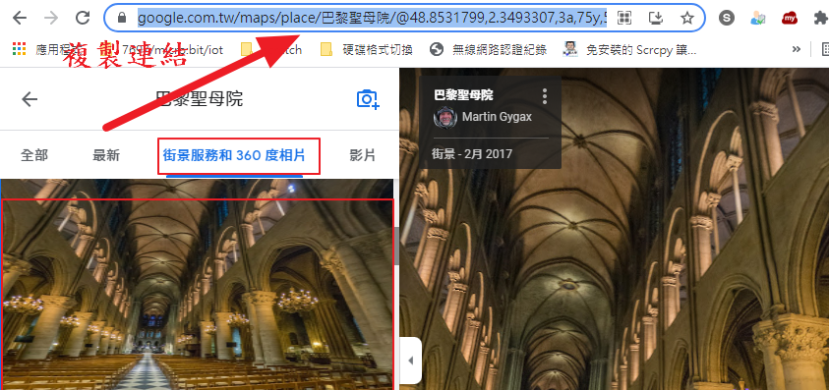

**3. 將複製的連結，貼上軟體的TOOLS，會產生一組 Panorama ID。再 複製此組 ID 。**

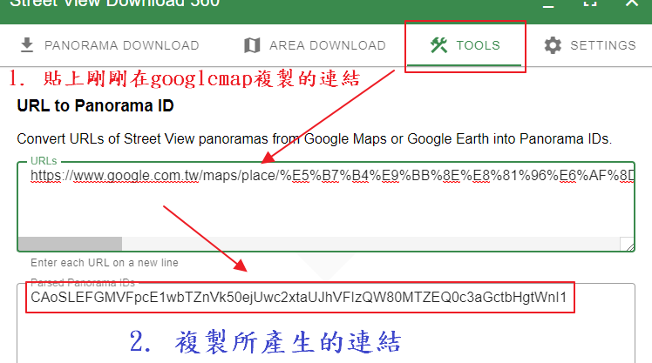

**4. 將複製的Panorama ID，貼上軟體的DOWNLOAD。選擇存檔位置，選擇圖片解析度（最大的13312X6656) 下載此張 360 pic 。**

**重複(二)~(四)步驟，下載2張360照片**

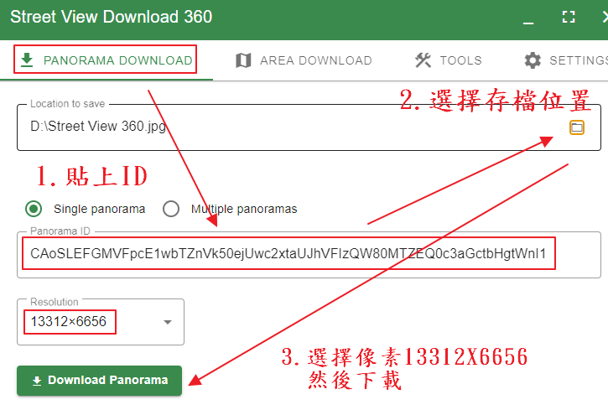

**↑↑↑↑↑以上供參↑↑↑↑↑**

**(二) 至** [**RoundMe VR**](https://www.google.com/url?q=https%3A%2F%2Froundme.com%2F&sa=D&sntz=1&usg=AOvVaw3AYN7qvcL-6W_S_Ao12DwC) **製作網站，**

**以Google教育帳號進行註冊。**



**(三) 同意其條款，才可以使用。**

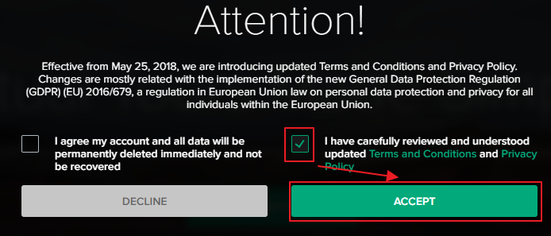

**(四) 開始專案->**

**上傳360照片。**

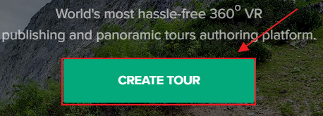

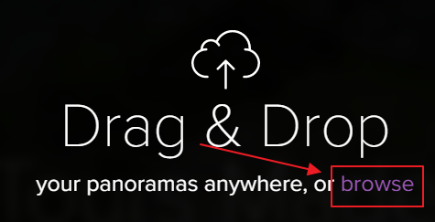

**(五) 新增景點名稱:xxxx**

**描述: 9xxxxOOO(班級座號姓名)**

**下方: 務必 Published 才看得到**

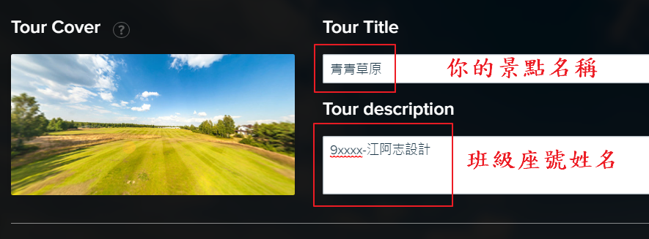



**(六) 右上角編輯畫面**

**1.切換 瀏覽/編輯 模式**

**2.上傳另外360照片**

**3.增加圖上景點詳細說明**

**4.可增加音效**

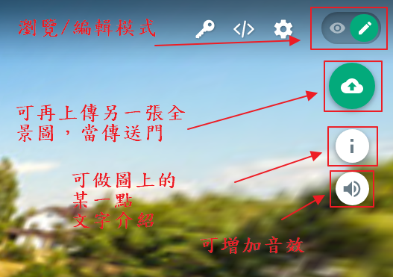

**(七) 新增另一張360照片**

**1.下方會出現場景照片**

**2.將景點拖曳至指定位置**

**3.命名**

**4.調整360場景開始視角**

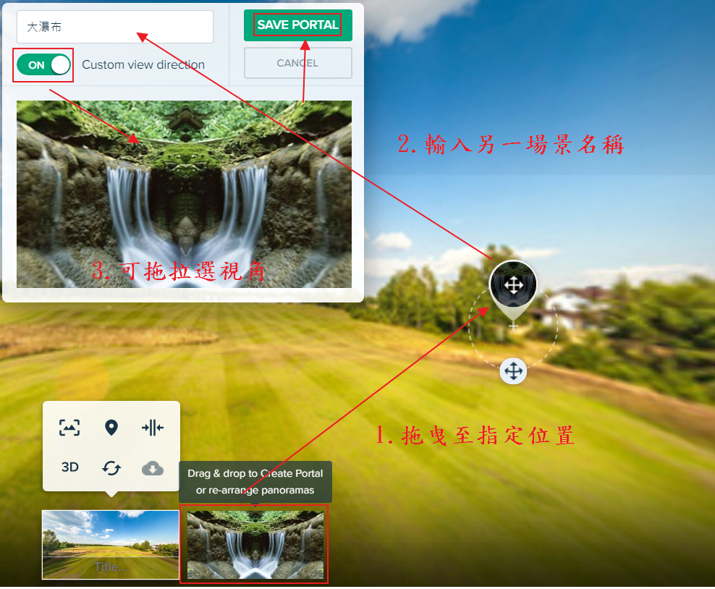

**(八) 新增一個景點介紹**

**1.拖曳至你想要的位置**

**2.輸入標題、詳細資料**

**3.確認**

**4.也可再額外增加圖片**

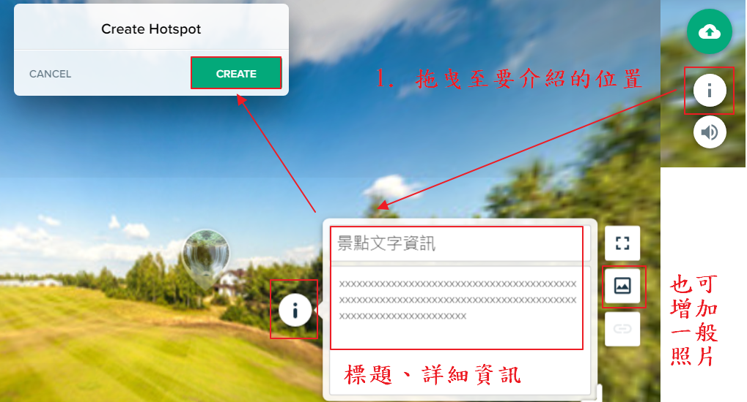

**(九) 完成後複製 瀏覽網址 (不是編輯網址喔!!)**

**貼到原本的qrcode網頁。下載此個QR-code。**

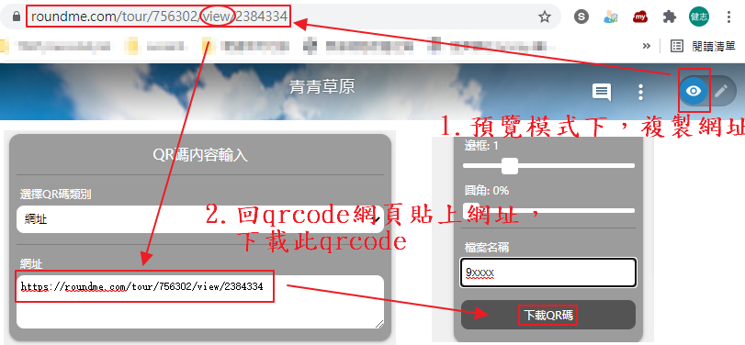

**!!! 請將此檔案 9xxxx.png 繳交至作業繳交區!!!**

**(十) 請用手機掃描 QR-CODE**

**將網頁調整至WebVR-mode**

**將手機放入VR-BOX**

**即可享受自製的VR場景世界。**

