**本土雙語教育模式之建構與推廣：以臺灣國中小為現場之實踐**

**雙語課程教案設計**

**The Design of Bilingual Lesson Plan**

※以下表格採中文或英文填寫皆可，然鼓勵以英文填寫。The blanks can be filled in Chinese or English, but English is encouraged.

※雙語教案撰寫時，請使用中字標楷體、英字Times New Roman、字體12、單行距，並以Word及PDF檔案進行繳交。

|  |  |  |  |  |  |  |
| --- | --- | --- | --- | --- | --- | --- |
| **學校名稱**  **School** | | 基隆市尚仁國小 | | **課程名稱**  **Course** | 色彩實驗室 | |
| **單元名稱**  **Unit** | | 色彩實驗室 | | **學科領域**  **Domain/ Subject** | 藝術 | |
| **教材來源**  **Teaching Material** | | 康軒教科書 | | **教案設計者**  **Designer** | 鄭詠文 | |
| **實施年級**  **Grade** | | 4 | | **本單元共3節**  **The Total Number of Sessions in this Unit** | | |
| **教學設計理念**  **Rationale for Instructional Design** | | 學習正確使用水性顏料，透過水性顏料加水、混色，體驗色彩的各種變化，發現色彩間的關係。 | | | | |
| **學科核心素養**  **對應內容**  **Contents Corresponding to the Domain/Subject Core Competences** | | **總綱**  **General Guidelines** | 具備藝術感知、創作與鑑賞能力，體會藝術文化之美，透過生活美學的省思，豐富美感體驗， 培養對美善的人事物，進行賞析、建構與分享的態度與能力。 | | | |
| **領綱**  **Domain/Subject Guidelines** | 藝-E-B1 理解藝術符號，以表達情意觀點。  藝-E-B3 善用多元感官，察覺感知藝術與生活的關聯，以豐富美感經驗。 | | | |
| **校本素養指標**  **School-based Competences** | ※若無則免填。Please skip if there is no school-based curricula. | | | |
| **學科學習重點**  **Learning Focus** | | **學習表現**  **Learning Performance** | 1-II-3 能試探媒材特性與技法，進行創作。  ※請填寫最重要的二至三項。Please specify the most important two or three items. | | | |
| **學習內容**  **Learning**  **Contents** | 視E-II-1 色彩感知、造形與空間的探索。  視E-II-2 媒材、技法及工具知能。  ※請填寫最重要的二至三項。Please specify the most important two or three items. | | | |
| **學生準備度**  **Students’ Readiness** | | 學科準備度 Readiness of Domain/Subject  學生在三年級學習觀察、收集生活中的色彩，運用這些色彩進行拼貼重組再現。 | | | | |
| 英語準備度 Readiness of English  學生已熟悉顏色和形狀基本單字和句子。  學生已熟悉教室規則單字和句子。  ※英語準備度指學生上課前已學習過的英語單字及句型，可參考計畫網頁的國中小English readiness，或請教教該年級的英語教師。Readiness of English means the vocabulary or sentences that students already learned. Check the Bilingual Taiwan website or ask the English teachers who teach students of this grade. | | | | |
| **單元學習目標**  **Learning Objectives** | | **表現**  1.能正確使用水性顏料與工具，體驗調色、混色。  2.能調出不同色彩並進行創作。 | | | | |
| **中／英文**  **使用時機**  **Timing for Using Chinese/ English**  ※請填寫清楚何時、何處使用中/英文。  Please describe in detail when and where you use Chinese/English. | | **教師 Teacher** | | | **學生 Students** | |
| 使用時機   * T greet student * T do class management * T introduce the main concepts | | | 使用時機   * S respond to T’s greeting * S say names of colors. * S introduce their works * S listen to the introduction of main concepts. | |
| **教學方法**  **Teaching Methods** | | 講述式教學，練習法 | | | | |
| **教學策略**  **Teaching Strategies** | | 設計提問，搭建鷹架 | | | | |
| **教學資源及輔助器材**  **Teaching Resources and Aids** | | 學習單，簡報，投影機，水彩，水彩筆，調色盤，抹布，水洗盆，色紙 | | | | |
| **評量方法**  **Assessment Methods** | | 口語評量，紙筆評量，表現評量 | | | | |
| **評量規準**  **Rubrics** | | 1. 能運用水彩畫出淺色和深色的圖案。 2. 能運用水彩調色繪製出六色相環。  |  |  |  |  | | --- | --- | --- | --- | | 項目/得分 | 3 | 2 | 1 | | A | 能正確運用水彩畫出淺色和深色圖案各3個。 | 能正確運用水彩畫出淺色和深色圖案各2個。 | 僅能運用水彩畫出一個或以下的深色或淺色圖案 | | B | 能正確運用水彩混合出三種顏色(紫色，橘色，綠色) | 能正確運用水彩混合出二種顏色 | 能運用水彩混合出一種顏色或以下 | | | | | |
| **議題融入**  **Issues Integrated** | | ※無則免填，若有，請填寫至多兩項。Please write down no more than two issues if there is any. | | | | |
| **教學流程 Teaching Procedures**  ※以下欄位若活動內容是需要使用英文進行，請以英文撰寫，並須依據前面的中/英文使用時機撰寫。Please use English to specify your teaching activities that are executed in English in the classroom based on the timing for using Chinese/English section. | | | | | | |
| **第一節** | **準備階段 Preparation stage**   1. Art appreciation 2. Look at the picuture. What do you see? 3. Tell me what makes watercolor paintings special.   **發展階段 Development stage**   1. Introduce waterolors tools. 2. Let’s see what we need for watercolor painting. 3. What’s this? (palette, water container, watercolors, watercolor brushes, rag) 4. How to use tools. 5. Squeeze some watercolor onto the palette. 6. Mix them with water. 7. Paint on paper. 8. Wash the brushes well. 9. Dry the brush 10. Some tips.     1. Don’t leave brushes standing in water.     2. Re-shape the bristles with your fingers before they dry.   **總結階段 Summary stage**   1. 複習水彩用具和使用方法。   **第一節結束 End of the first session** | | | | | **時間 Time** |
| 8  20  12 |
| **第二節** | **準備階段 Preparation stage**   1. Art appreciation 2. Let’s see some paintings. 3. What kinds of lines do you see? 4. Do you see light lines? Where are they? 5. Do you see dark lines? Where are they? 6. Art tips: dip – paint—wash off – dry the brush.   **發展階段 Development stage**   1. Line painting 2. Each student gets one piece of drawing paper. 3. Choose a paint. Put some into the palette. 4. Put more paint and mix it with lots of water. 5. Paint some dark lines. Try and create a picture. 6. Paint some light lines. Try and create a picture.   **總結階段 Summary stage**   1. Are you done with the coloring? 2. Show your works to your friends. Tell how you used light and dark lines. 3. Clean up your desk.   **第二節結束 End of the second session** | | | | | 8  20  12 |
| **第三節** | **準備階段 Preparation stage**  Color wheel   1. What colors do you see in the middle? 2. Red, yellow, blue are primary colors. 3. How can we get green? Blue and yellow makes green. 4. How can we get orange? Red and yellow makes orange. 5. How can we get purple? Red and blue makes purple.   Arrange the tools  Introduce waterolors tools.   1. Let’s see what we need for watercolor painting.   **發展階段 Development stage**  Make color wheel   1. Each student gets one piece of drawing paper. 2. Squeeze the red, yellow, blue paints onto the palette. 3. Art tips: dip – paint—wash off – dry the brush – color. 4. Blue and yellow makes green. 5. Color it green.   **總結階段 Summary stage**  T: what we have learned today.  **第三節結束 End of the third session** | | | | | 10  20  10 |
| **參考資料**  **References** | | <https://www.watercoloraffair.com/how-to-make-a-12-color-watercolor-wheel/>  <https://mrprintables.com/printable-color-wheel.html>  https://youtu.be/eGrGkJtSLsk | | | | |

※期待雙語教師能逐年使用更多英文撰寫本教案。We are looking forward that you can use more and more English to write this lesson plan year by year

Name: ______________

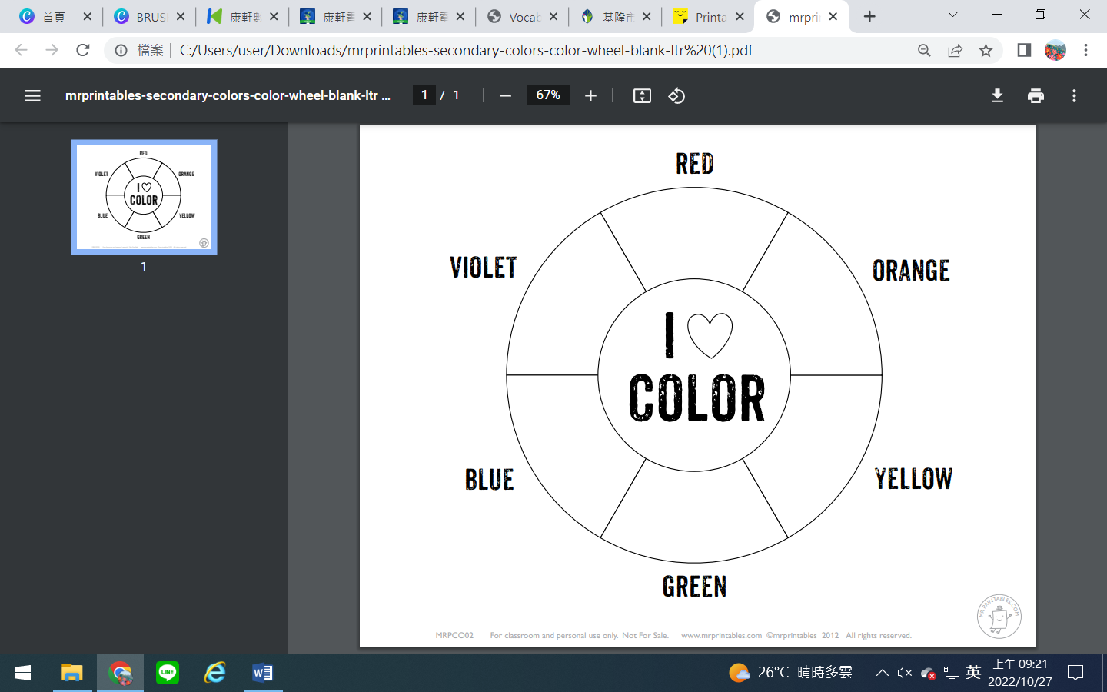Color wheel

https://mrprintables.com/printable-color-wheel.html