學校名稱  School |  | 基隆市信義國小 |  | 課程名稱  Course | 國際教育
單元名稱  Unit |  | Goal!2022 |  | 學科領域  Domain/ Subject | 其他領域:彈性國際教育
教材來源  Teaching Material |  | Teacher-designed |  | 教案設計者  Designer | 廖彩妤
實施年級  Grade |  | 5 |  | 本單元共 4 節  The Total Number of Sessions in this Unit
教學設計理念  Rationale for Instructional Design |  | 2022年國際足聯男子世界杯（FIFA Men's World Cup）賽事將於11月進行，首次在年末進行，也是世界杯歷史上第一次由中東國家主辦。  利用時事融入國際教育，引導五年級學生將生活與英語連結，且透過世界杯足球賽引發學生學習英語興趣及國際文化素養，表達個人意見。  藉此豐富學生雙語語言學習， 營造真實雙語情境之生活化，培養學生多元國際觀點。
學科核心素養  對應內容  Contents Corresponding to the Domain/Subject Core Competences |  | 總綱  General Guidelines | B1 符號運用與溝通表達
 |  | 領綱  Domain/Subject Guidelines | 英-E-B1 具備入門的聽、說、讀、寫英語文能力。在引導 下，能運用所學、字詞及句型進行簡易日常溝通。
 |  | 校本素養指標  School-based Competences | ※若無則免填。Please skip if there is no school-based curricula.
學科學習重點  Learning Focus |  | 學習表現  Learning Performance | 英5-Ⅲ-4 能聽懂日常生活應對中常用語句，並能作適當的回應。  英 6-Ⅲ-5樂於接觸課外英語學習素材。
 |  | 學習內容  Learning  Contents | B-Ⅲ-2 國小階段所學字詞及句型的生活溝通。  C-Ⅲ-2 國內外主要節慶習俗。
學生準備度  Students’ Readiness |  | - Students can uses basic English to express their ideas.  - Students can help each other to do the task.  - Students can use various ways to communicate to each other.
英語準備度 Readiness of English
- 學生上課前已學習過基礎英語單字與句型
單元學習目標  Learning Objectives |  | - Students would be able to use the pattern to express their ideas.  - Students would be able to express the following patterns of a dialogue.  - Who are you supporting in the 2022 World Cup?  - I support Qatar.  - Students would be able to use the following patterns to write the sentences.  - I see . (I see you waving your hands.)  - I hear . (I hear your voice.)  - Great/best/Good  - Students would be able to working on pair activity
中／英文  使用時機  Timing for Using Chinese/ English  ※請填寫清楚何時、何處使用中/英文。  Please describe in detail when and where you use Chinese/English. |  | 教師 Teacher |  |  | 學生 Students
 |  | 英文:  1.課堂中暖身及指示用語  2.講解活動規則及鼓勵回饋  中文:  足球規則及學生有疑問的時刻 |  |  | 英文  1.用基礎英文表達想法  2.練習英語句型  3.鼓勵及教室用語
教學方法  Teaching Methods |  | 討論法  聽寫教學  合作學習教學  遊戲教學
教學策略  Teaching Strategies |  | 異質小組合作學習  真實情境教學  多媒體交互學習
教學資源及輔助器材  Teaching Resources and Aids |  | 電腦設備、投影機、小白板丶 白板筆、教材,學習單、海報紙
評量方法  Assessment Methods |  | Performance assessment.
評量規準  Rubrics |  | Performance assessment:  個人及小組加分(根據學習表現給予分數)
議題融入  Issues Integrated |  | 國際教育  養成參與國際活動的知能
教學流程 Teaching Procedures
第一節 | 準備階段 Preparation stage  - Warm up  - Picture Walk  - T shows slides “The mascot for Qatar 2022 ”, asks Students to guess “Where are they doing “and links up to today’s topic “FIFA WORLD CUP 2022”.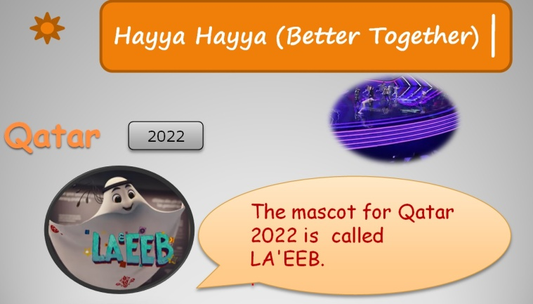  發展階段 Development stage  - Presentations  - Listening the song  - T plays the MV of the song “Hayya Hayya (Better Together)” (music from the FIFA world cup Qatar 2022 official soundtrack).  - T plays the RT of the song Hayya Hayya.  - Drilling the lyrics: T-C→G/G→S/S  - Singing the song together.  - Activities  - Task: “To think about the World Cup 2022 ”  - T writes down the rules of the World Cup on the board.  - T: “Please look around the rules, and ask questions”  - Students use their questions to introduce the rules of the World Cup.  - T draws a“?” on the board to collect the Students’ patterns.  總結階段 Summary stage  - Worksheet  - Task: “How hot is it in Qatar”  - T instructs students to think and find the ways to solve the problem.  - Students fill in the blanks at the bottom of the worksheet.  - Wrap up  - Review: T review the content of today’s class briefly.  - Assignment: T assigns the worksheet to students and explains how to do it. |  |  |  |  | 時間 Time
5分鐘

25分鐘

10分鐘

