簡易教案
引起動機
https://www.youtube.com/watch?v=DPyBNlnADwc
T: What is she doing?
Ss respond.
主要活動
T: We can make our own cleaner.
T demonstrates how to make a cleaner.
Step1: Put the pomelo peel on the jar.
Step2: Add liquids to cover the peel and put the lid on.
Step3: Wait a week.
Step4: Stain the peel.
Step5: Pour the pomelos into the jar.

統整活動
Ss finish the worksheet and then get water they count from the worksheet. Put the liquids into the jar on their desk.

Make cleaner
liquids
Alcohol*1 | Foaming agent*1 | Water*3
40ml | 40ml | 120ml
75ml | 75ml | 225ml
200ml | 200ml | 600ml
********************************************************************
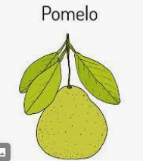  One pomelo |  | 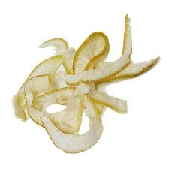  200g
Two pomelos |  | 400g
How many pomelos do you need?  I need ___________ pomelos. |  | 1000g

