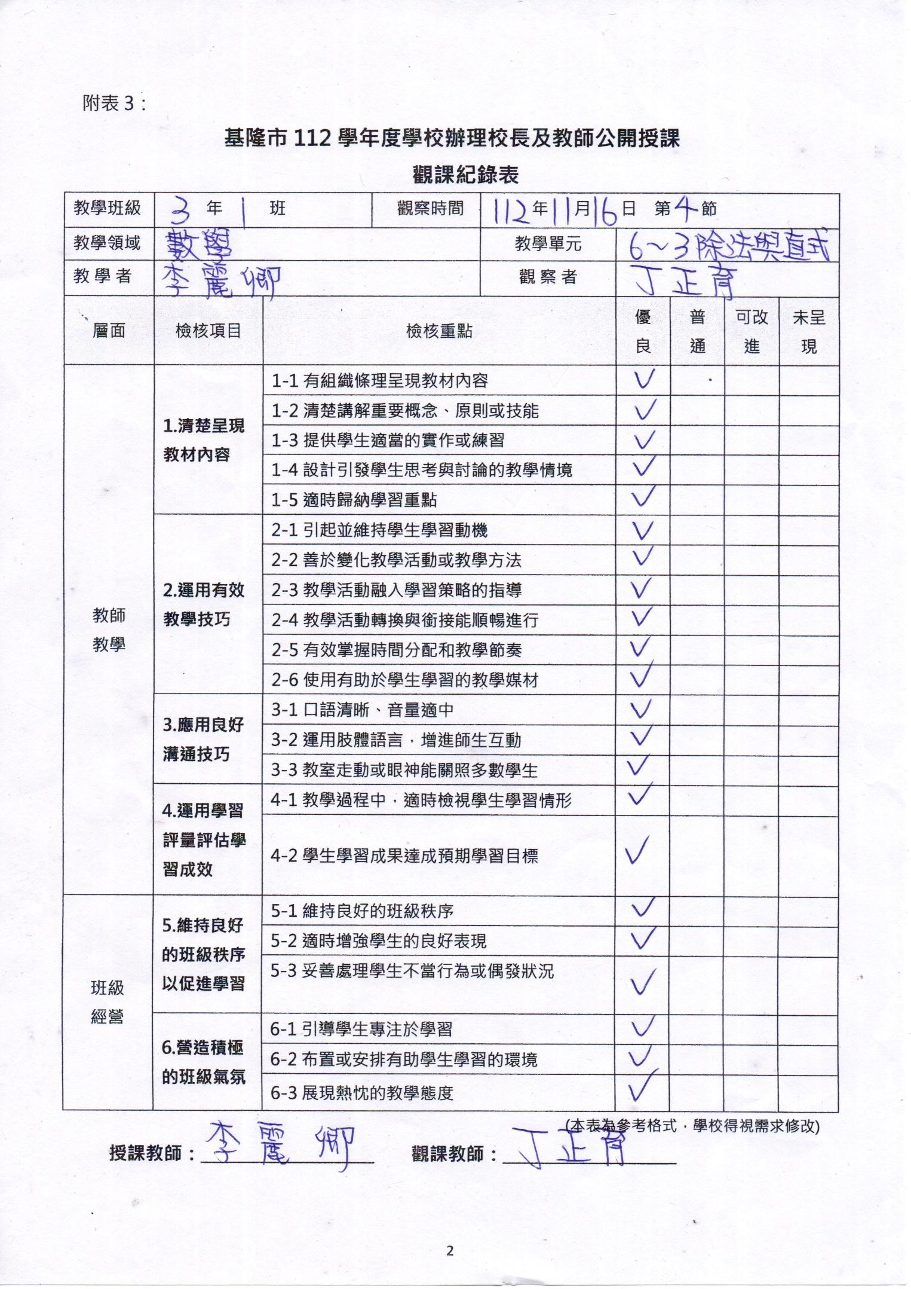

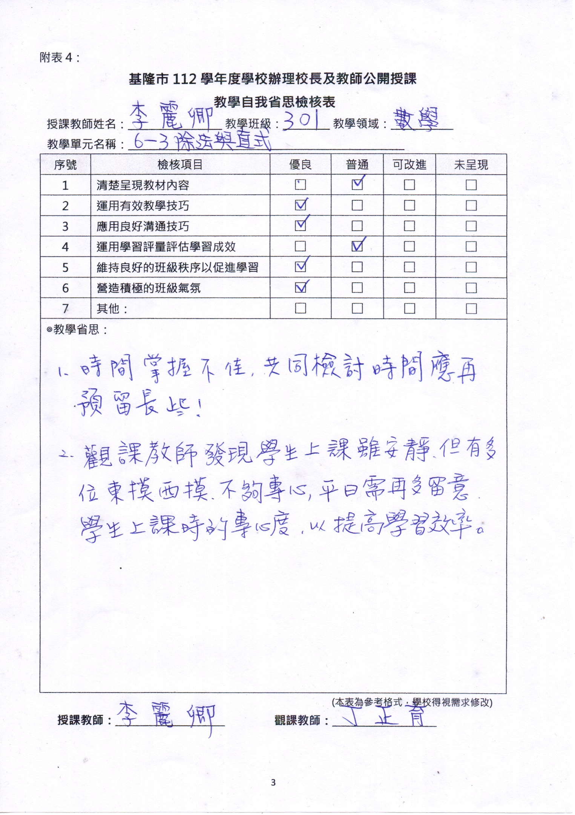

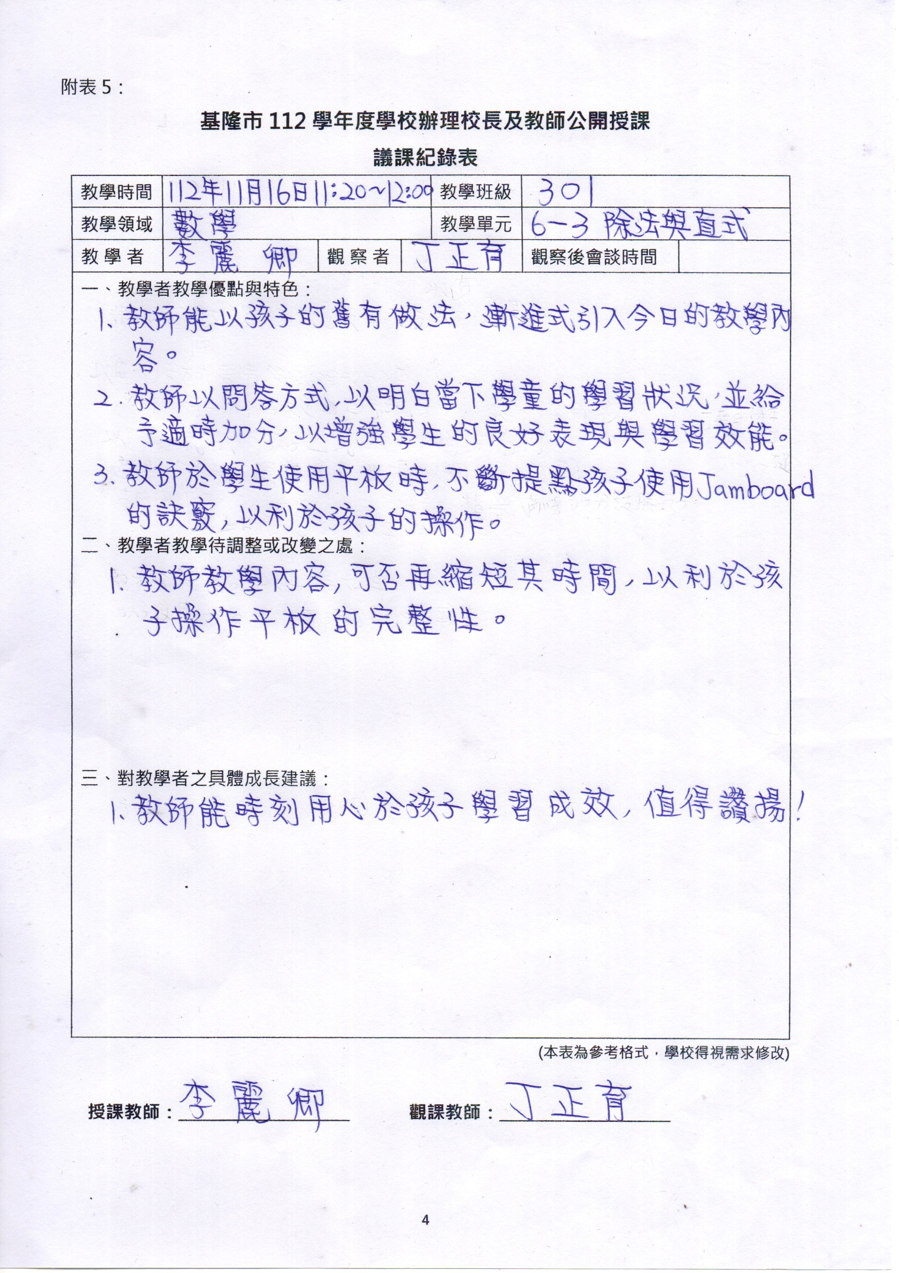

|  |
| --- |
| C:\Users\user.DESKTOP-MU0QJ84\Downloads\LINE_ALBUM_1121116公觀課_231121_1.jpg |
| 除法直式說明 |
| C:\Users\user.DESKTOP-MU0QJ84\Downloads\LINE_ALBUM_1121116公觀課_231121_4.jpg |
| 上臺回答意願踴躍 |
| C:\Users\user.DESKTOP-MU0QJ84\Downloads\LINE_ALBUM_1121116公觀課_231121_5.jpg |
| 學生JAMBOARD線上作業練習 |
| C:\Users\user.DESKTOP-MU0QJ84\Downloads\LINE_ALBUM_1121116公觀課_231121_3.jpg |
| 學生JAMBOARD線上作業練習 |