教育部國民及學前教育署補助國民中小學部分領域課程雙語教學實施計畫
本土雙語教育模式之建構與推廣：以臺灣國中小為現場之實踐

本土雙語教育模式之建構與推廣：以臺灣國中小為現場之實踐
雙語課程教案設計
The Design of Bilingual Lesson Plan

學校名稱  School |  | 基隆市暖暖國小 |  | 課程名稱  Course |  | 熱與火的危機
單元名稱  Unit |  | - 小心灼燙傷  - 防火安全檢查  - 火場應變 |  | 學科領域  Domain/ Subject |  | 健體領域
教材來源  Teaching Material |  | 康軒四上 健康與體育 |  | 教案設計者  Designer |  | 廖憶雯
實施年級  Grade |  | 國小四年級 |  | 本單元共 9 節  The Total Number of Sessions in this Unit
教學設計理念  Rationale for Instructional Design |  | 生活中潛藏著各種危機, 本單元帶領學生認識的潛在危機為灼燙傷和火災。在主題「灼燙傷｣中, 認識灼燙傷的種類, 覺察造成灼燙傷的可能原因, 了解預防灼燙傷的方法, 學習灼燙傷的急救處理方法。在主題「火災｣中, 認識用電安全, 了解不安全的用電方式容易引發火災。接著, 認識居家、公共場所的防火措施, 澄清火災逃生避難的迷思, 演練火災逃生避難原則和技巧。
學科核心素養  對應內容  Contents Corresponding to the Domain/Subject Core Competences |  | 總綱  General Guidelines | A2 系統思考 與 解決問題  A3 規劃執行 與 創新應變  C2 人際關係 與 團隊合作
 |  | 領綱  Domain/Subject Guidelines | 健體-E-A2 具備探索身體活動與健康生活問題的思考能力, 並透過體驗與實踐, 處理日常生活中運動與健康的問題。
 |  | 校本素養指標  School-based Competences | 無
學科學習重點  Learning Focus |  | 學習表現  Learning Performance | 1b-II-1 認識健康技能和生活技能對健康維護的重要性。  2b-II-1 遵守健康的生活規範。  3a-II-1 演練基本的健康技能。
 |  | 學習內容  Learning  Contents | Ba-II-1 居家、交通及戶外環境的潛在危機與安全須知。  Ba-II-2 灼燙傷、出血、扭傷的急救處理方法。  Ba-II-3 防火、防震、防颱措施及逃生避難基本技巧。
學生準備度  Students’ Readiness |  | 學科準備度 Readiness of Domain/Subject  火與生活的連結、火災新聞報導、基本防災用品及動線、公車安全須知
英語準備度 Readiness of English
- 能聽懂並做出常用的教室用語。
- 能聽懂5W問句, 並能有簡單的回應。
單元學習目標  Learning Objectives |  | 3-1 小心灼燙傷(2節)  - 學習與灼燙傷者相處。  - 了解造成灼燙傷的可能原因和預防灼燙傷的方法。  - 在生活中獨立操作灼燙傷的急救處理方法。  3-2 防火安全檢查(5節)  - 了解並遵守居家安全注意事項。  - 了解居家防火措施及滅火器使用方法。  3-3 火場應變(2節)  - 演練發現火災時的應變方式及澄清火災逃生避難的迷思。
中／英文  使用時機  Timing for Using Chinese/ English |  | 教師 Teacher |  |  | 學生 Students
 |  | 中文使用時機:  - 學生經過老師引導, 尚無法理解教學活動, 予以中文輔助。  - 學生有安全相關的事項。  - 重要概念說明。  英文使用時機:  - 教室用語、課堂秩序管理。  - 部份任務指導語及目標句型。  - 重述學生以中文發表之內容。 |  |  | 中文使用時機:  - 英語用字或句型較艱深時。  - 詳述自己想法時。  - 學生可自行決定使用中文的時機。  英文使用時機:  - 使用Yes/No答句回答教師問題時。  - 使用關鍵字或句型回答教師指導語。
教學方法  Teaching Methods |  | 小組討論法、示範教學法、講述法。
教學策略  Teaching Strategies |  | 學科: 搭建鷹架、連結生活經驗、運用多媒體影音促進雙語溝通互動、設計提問、小組活動展現學習成果、學習單展現學習歷程與成效、情境脈絡學習  語言: 設定相關的句型及重點單字, 讓學生練習使用。
教學資源及輔助器材  Teaching Resources and Aids |  | 自製PPT、自製學習單共5份、YouTube影音資源、文具用品、著色用具
評量方法  Assessment Methods |  | 口頭評量、實作評量、檔案評量
評量規準  Rubrics |  | 單元名稱 A B C D  3-1 小心灼燙傷 1.針對事件能說出其預防方式。 2. 能說出發生這些灼燙傷的原因。 3.能說出要如何才能 “Stay Safe” 1.針對事件能說出其預防方式。 2. 能說出發生這些灼燙傷的原因。 針對事件能說出其預防方式。 未達C級
議題融入  Issues Integrated |  | - 安E11 了解急救的重要性。  - 安E4 探討日常生活應該注意的安全。
3-1 小心灼燙傷 (共2節)
教學流程 Teaching Procedures
第一節  (演示)  灼燙傷類型  傷後情緒  增加理解  What is灼燙傷  Why灼燙傷happen  預防方法?  How to stay safe | 準備階段 Preparation stage  - Roll Call & Classroom Greetings  T: Who is absent?  T: Class leader! 複習Classroom rules  1. Raise your hands.  2. No yelling.  - 導入主題: 小心灼燙傷  以臉部平權影片導入引起動機  https://www.youtube.com/watch?v=4nRCrToOkB0  2022臉部平權-口罩篇  發展階段 Development stage  (一)引起動機  - 教師以5W提問學生從影片中觀察到的資訊  T: What happened?  T: What’s wrong?  T: Why does she wear a mask?  T: Think about it. How does she feel?  T: Yes, she may __________.  (參考答案: feel terrible, feel painful, feel scared, feel sad，以圖示舉例引導學生進一步說明)  T: She wears a mask because she’s scared. People will look, and people don’t know what happened.  T: So, what can we do for them?  老師以 “Yes/No”的方式, 引導學生判斷應該怎麼做。  (教師搭配圖片提供參考答案: care about them more, respect them, laugh at them, tell jokes about them, help them, look at them a lot)  T: We can _____________.  引導學生以上述句型回覆出答案。  We need to know more to help? (學生可以中文回答)  2. 教師搭配PPT, 介紹造成灼燙傷的原因及種類, 還有其預防方法。  T: These are all burns. Burns can be from a fire, chemicals, hot liquids or electrical. Fire can be good or bad. We need to know how to use it safe.  T: Here are 5 pieces sticky notes, one for each section, please come and stick one note in each section.  老師逐項介紹上述灼燙傷後, 準備一大張海報, 如下:  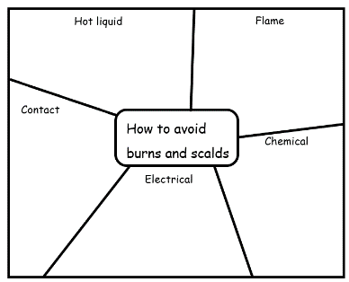  請學生就所知道的方法, 以便利貼貼在對應的地方。  總結階段 Summary stage  - 以影片結尾, 再次強調尊重他人的重要。https://www.youtube.com/watch?v=Q55oDhvJPoY  臉部平權 從你我開始  T: Please remember “Face Equality”, we are the same.  - 發下學習單, 如下:  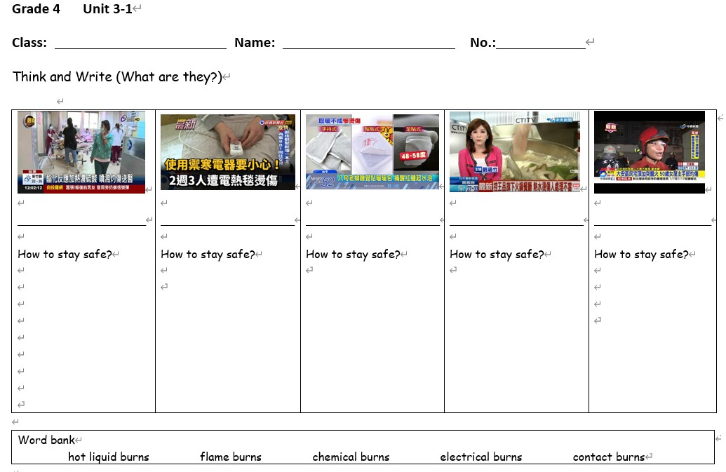  T: This is the homework today, we’ll discuss it next time.  第一節結束 End of the first period |  |  |  |  |  | 時間 Time

