1121208公開授課教案設計
服務學校 |  | 基隆市仁愛國小 |  | 設計者 |  | 黃庭芬
領域/科目 |  | 英語領域 |  | 實施年級 |  | 五年級
單元名稱 |  | 自編課程  (Christmas around the World) |  | 總節數 |  | 共__1__節，__40__分鐘
行動載具  作業系統 |  | □Android系統 ■Chrome系統 □iOS系統 ■Windows系統
設計依據
學習  重點 | 學習表現 |  | 5-Ⅱ-2 在聽讀時，能辨識書本中相對應的書寫文字。  6-Ⅱ-3 樂於回答教師或同學所提的問題。  6-Ⅱ-4 認真完成教師交待的作業。  8-Ⅱ-3 能了解課堂中所介紹的國外主要節慶習俗。 |  | 核心  素養 |  | 英-E-B2  具備使用各種資訊科技媒材進行自我學習的能力，以增進英語文聽說讀寫綜合應用能力及文化習俗之理解。
 | 學習內容 |  | C-Ⅱ-2 國內外主要節慶習俗。
議題  融入 | 實質內涵
 | 所融入之學習重點
與其他領域/科目的連結 |  |  | - 英語領域  - 社會領域
教材來源 |  |  | 翰林Here We Go B5 - culture : Christmas, 自編補充教材
教學設備/資源 |  |  | Windows筆電
使用軟體、數位資源或APP內容 |  |  | Wordwall, Padlet, Chat Everywhere, YouTube
學習目標
- 學會聖誕節相關單字及句型。
[Santa Claus, gift, stocking, Christmas tree, bell, January, December]
[Merry Christmas. Let’s open the gift.]
[What to do in ____ for Christmas?]
[How do people celebrate Christmas in ______?]
5-Ⅱ-2

- 運用數位資源搜尋並整理各國聖誕節慶祝的相關活動及內容。
6-Ⅱ-3、6-Ⅱ-4、8-Ⅱ-3

- 了解各國地理位置及聖誕節慶文化。
8-Ⅱ-3
學生背景知識
- 已了解聖誕節精神及概念
- 能運用Phonics拼讀簡易單字
- 了解如何運用數位工具收集資料，公告資訊

教學活動設計
教學活動內容及實施方式 |  | 時間 | 使用軟體、數位資源或APP內容
- 學生自學  引起動機：  1.教師揭示本節學習重點為認識聖誕節慶文化。  2.請學生進入班級Padlet，觀看YouTube影片，再到Wordwall進行遊戲測驗。  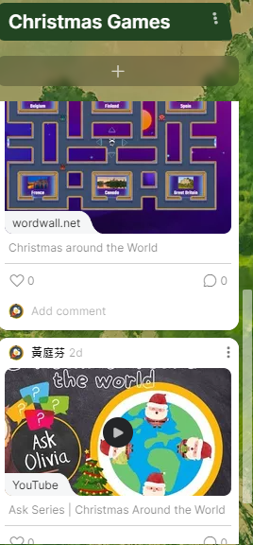  - 教師導學  1.老師提問Wordwall測驗內容。  2.引導各組學生查詢各國地理位置，並利用提問Chat Everywhere，蒐集各組代表國家的聖誕節慶祝活動。  How do people celebrate Christmas in _____?  What to do in ____ for Christmas?  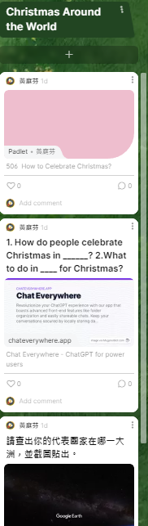  - 學生自學  - 組內共學  1.請學生在Padlet討論區寫下不同國家的  聖誕節慶祝活動2~3項。  - 組間互學  2.觀察不同小組的資料，並在Padlet留言  提問各1則。  3.小組討論回覆提問，並請小組代表上台  分享並回應。  - 教師導學  1.教師統整歸納各個國家不同的聖誕節慶祝文化。  2.派發Wordwall測驗評量至Classroom。 |  | 10分  5分  5分  5分  10分  5分 | 電子書  Padlet  Wordwall  Chat Everywhere  Google Earth  Padlet
參考資料 | Wordwall:Christmas around the World  https://wordwall.net/play/64999/604/375  YouTube:Christmas around the World  https://youtu.be/g7Ei78g65cU?si=E4wyAhLNjrTxKfuG  Google Earth  https://earth.google.com/web/?authuser=0  Chat Everywhere  https://chateverywhere.app/zh  Wordwall:Christmas around the World  https://wordwall.net/play/65147/636/383
附錄 | （學習單或其他相關資料）

