**Let’s learn something about 「SDGS」**

**Class Name**

1. What is SDGS meaning?
2. Write down 17 SDGS goals and darw it

|  |  |
| --- | --- |
| SDGS1: | SDGS2: |
|  |  |
| SDGS3: | SDGS4: |
|  |  |
| SDGS5: | SDGS6: |
|  |  |
| SDGS7: | SDGS8: |
|  |  |
| SDGS9: | SDGS10: |
|  |  |
| SDGS11: | SDGS12: |
|  |  |
| SDGS13: | SDGS14: |
|  |  |
| SDGS15: | SDGS16: |
|  |  |
| SDGS17: |  |
|  |  |

1. Which SDGS goals are you interested in?
2. Find your friends,then write down their goals and sign .

|  |  |  |
| --- | --- | --- |
|  |  |  |
|  |  |  |
|  |  |  |

5.BINGO!(choose 9 goals of SDGS and fill in)

|  |  |  |
| --- | --- | --- |
|  |  |  |
|  |  |  |
|  |  |  |

1. Share:今天我學到甚麼?

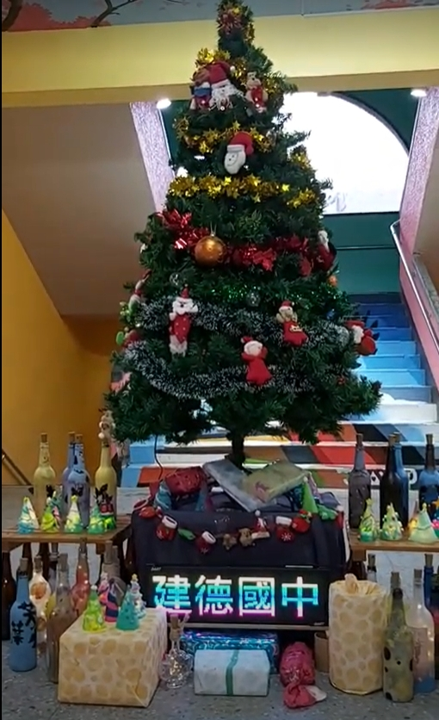 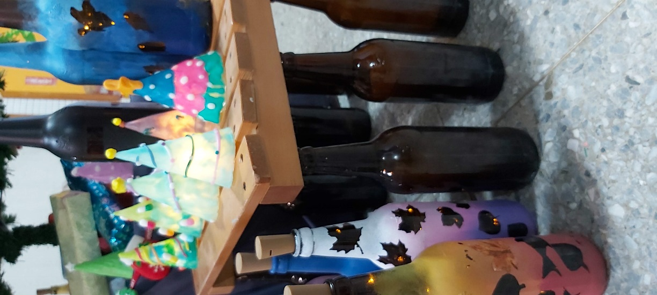

成果作品於112/12/25成為校園聖誕節校園裝飾~架子用廢棄課桌椅

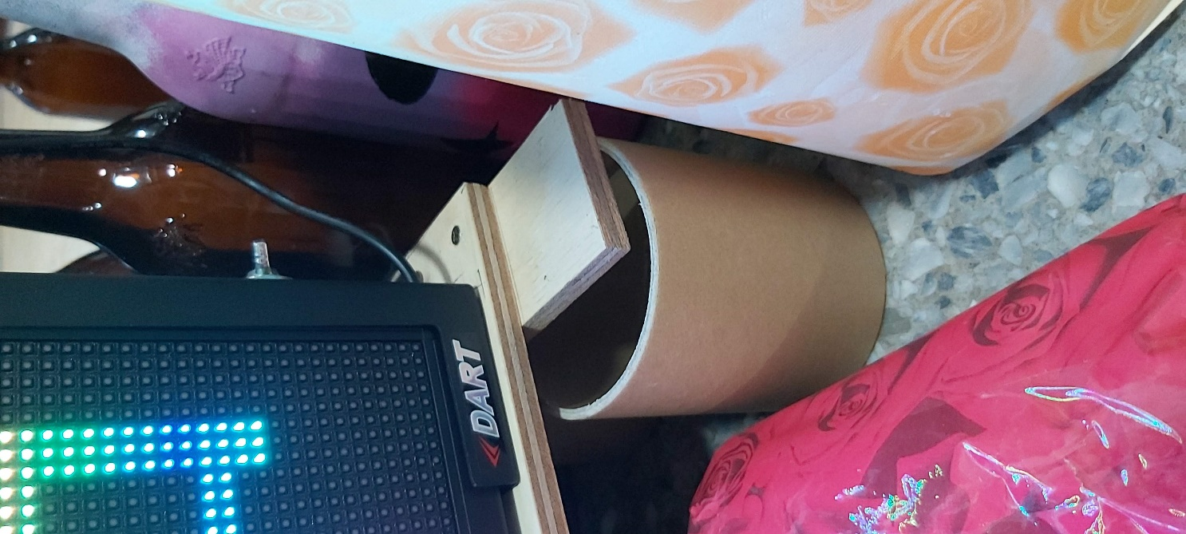 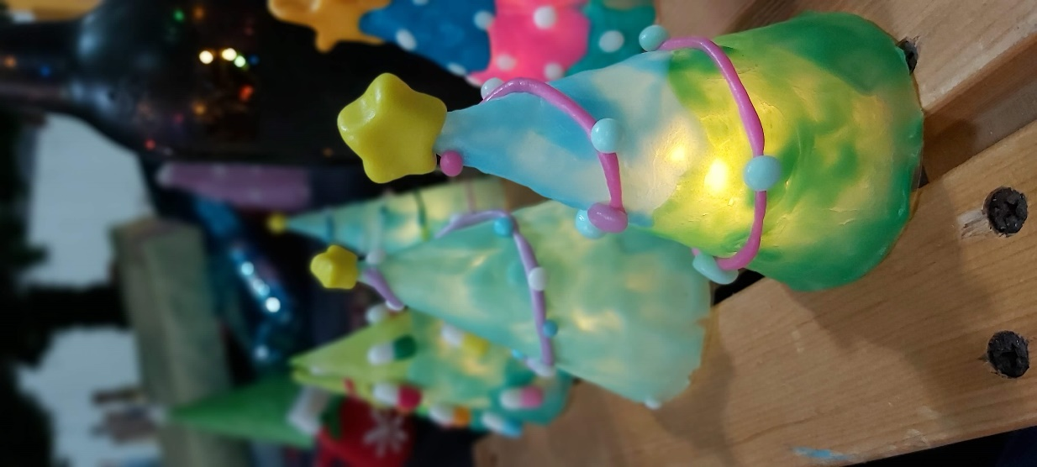

衛生紙卷也是可以再利用的好物~聖誕裝飾DIY明年還能繼續用: )