Keelung Jian De Junior High School Bilingual Lesson Plan

Domain/subject |  | Physical education |  |  | Teacher | Joel(楊耀中)
Grade Level |  | 9 |  |  | Time | 45 minutes
Session |  | second |  |  | Total number  of sessions | 4
Unit |  | volleyball - spike
Learning  Focuses | Learning Performance |  | 1c-IV-1 Be able to understand the principles and rules of sports.  3d-IV-2 Be able to use strategies in sports competitions.
 | Learning Content |  | Hb-IV-1 offensive-defensive actions and strategies in ball games.
Core competency |  |  | - Spontaneity  ■A1 Physical and Mental Wellness, and Self-Advancement  □ A2 Logical Thinking and Problem Solving  □ A3 Planning, Execution, Innovation, and Adaption  - Communication and Interaction  □ B1 Semiotics and Expression  □ B2 Information and Technology Literacy and Media Literacy  □ B3 Artistic Appreciation and Aesthetic Literacy  - Social Participation  □ C1 Moral Praxis and Citizenship  ■C2 Interpersonal Relationships and Teamwork  □ C3 Cultural and Global Understanding
Issue integrated |  |  | none
Teaching material |  |  | Revise from the textbook
Teaching aid |  |  | Whistle, whiteboard, volleyball, disc cone, notice board.
Teaching goal |  |  | - Students know the rules of volleyball.  - Students know the skills of volleyball.  - Cultivate team spirit.
Teaching activity design
procedure |  |  |  | activity |  |  | time
1 | preparation |  |  | - Warm up : Run 3 laps court and stretch body .  - Exercise :  (1)Push up - boy 15, girl 10.  (2)Jumping Jack - 30 seconds. |  |  | 15  mins
2 | presentation |  |  | - Introduce volleyball and English vocabulary.  - Demonstrate spike skills.  - Personal training  - Team training -  (1) four people a ball, use spike skill to pass the ball.  (2) Two lines, boys a team, girls a team, one person be a setter, practice spike with setter.  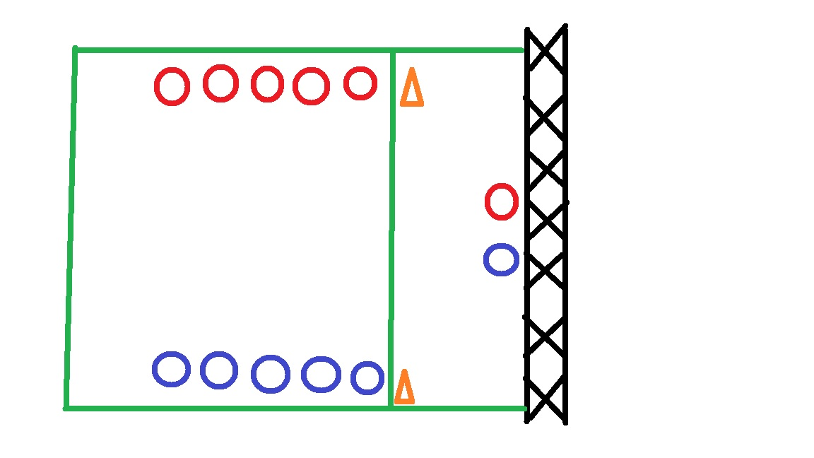 |  |  | 22  mins
3 | activity |  |  | - I am a spiker  Game - Two teams line up. Each player serves and spikes the ball to hit a target. The team with the highest score wins.  2. Feedback and review. |  |  | 8  mins
References
https://www.ctvba.org.tw/
https://www.fivb.com/

