B3 U3 Worksheet (Time & Past Continuous) Class:_________ Name:________

1. Use to/past;after to tell the time.(5%;40%)
2. 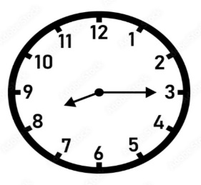_____________________ 2. 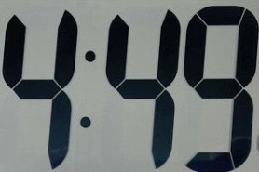 ____________________

3. 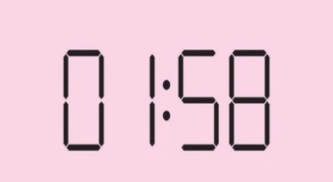____________________ 4. 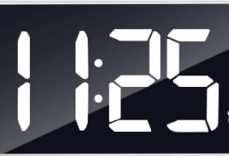_________________________

5. 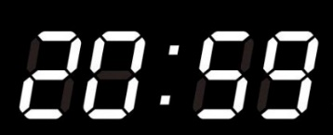____________________ 6. 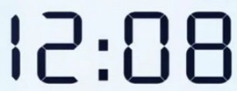_________________________

7. 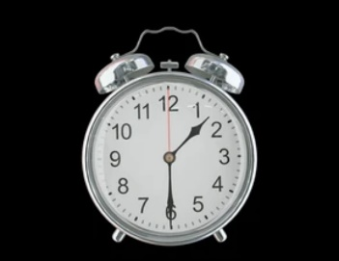____________________ 8. 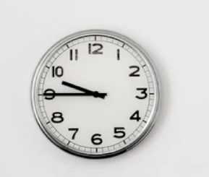_________________________

1. 依提示作答(10%;60%)
2. Annie was doing the dishes when Sam called her. (畫線造原問句)

____________________________________________________________________________________

1. Bonnie was listening to English songs at a quarter to nine last night. (畫線造原問句)

____________________________________________________________________________________

1. I was mopping the floor then. (畫線造原問句)

____________________________________________________________________________________

1. Wilson was breaking the window at half past one last Friday. (畫線造原問句)

____________________________________________________________________________________

1. Angel and Doris were sweeping the floor in the classroom then. (畫線造原問句)

____________________________________________________________________________________

1. Jack and Joinn mopped the floor this morning. (將this morning改成at that time改寫句子)

___________________________________________________________________________________