**基隆市立八斗高中國中部113學年度第1學期校內公開觀課教學計畫(1131107)**

|  |  |  |  |
| --- | --- | --- | --- |
| **日期** | **1131107(四)** | **時間** | **第二節09:10-10:00** |
| **授課單元** | **iEnglishB5U3**  **The Soldier Was Saved by a Dog** | **授課內容** | **Sentence Foucs:Passive Voice: be+V-pp** |
| **授課教師** | **蔡雅慧老師** | **授課班級** | **301班(20人)** |
| **授課時間** | **50分鐘** | **授課教室** | **語言教室** |
| 1. **暖身活動：**   **1.)複習文法句型A:** **被動式(be+V-pp):**  **人/動(事)物+ is/am/are(was/were) + V-ed(被動做…) + by (由…/受到…) + 動物/人**  **2.)複習文法句型B:** **未來/助動詞的被動式(will/should/can’t+be+V-pp):**  **人/動(事)物+ will(將)/should(應)/can’t(無法) + be + V-ed(被動做…) + in(在…)/to(去…)/by(受到…)+地點/人/動(事)物**  **※Grammar Focus**   |  |  |  |  |  | | --- | --- | --- | --- | --- | | **A** | The man | was | saved | by a dog. | |  | The notes | weren't | written | by my parents. | |  | English | is | spoken | (by people) around the world. | |  | The streets | aren't | cleaned | every day. | | **B** | | The story | will | be | reported | |  | | The benches | should | written | moved | |  | | The puppy | can't | spoken | found |  1. **教學活動：**   **分組練習活動：如附件一學習單(各組分工合作練習句型改寫)**  **1.)老師發給各組一張白紙、一隻彩色筆、一把剪刀、一張練習句型單。**  **2.)：各組先將老師發下去的學習單句型剪下來，並對折起來放置桌上備用。**  **將學生3-4人分成一組，分成剪紙人*1、抽籤人*1、手寫人*1、朗讀人*1**  **每組學生依分配的工作完成任務。**   1. **總結：** 2. **練習句型單解答。** 3. **給予各組學生獎勵。** 4. **分派作業或測驗。** | | | |

**附件一**

**Unit 3 The Soldier Was Saved by a Dog**

Class: 　　　　Name:

**Passive Voice**

Write and play. 將句子改成被動語態。

**Make Sentences**

規則：

(1) 三至四人一組，各組閱讀下方的句子，並改寫為被動語態。

例： The monkey attacked the elephant.

→ The elephant was attacked by the monkey.

(2) 各組剪下句子，折起來作籤。

(3) 各組進行分工：抽籤員*1、書寫員*1、檢查員*1–2。

(4) 教師發給各組一張白紙與彩色筆，計時兩分鐘，進行改寫句子競賽：各組抽籤員抽籤、書寫員將句子改為被動語態，寫在紙上、檢查員負責檢查句子是否有誤。注意！寫完句子才可抽下一張。寫得越快，在時限內就可以抽越多籤，分數也更高。

(5) 時間到，教師將白紙張貼於黑板上。各組的抽籤員與檢查員上臺，讀出自己組別的句子。

(6) 一個句子正確得一分，總分最高的組別獲勝。

**Sentences**

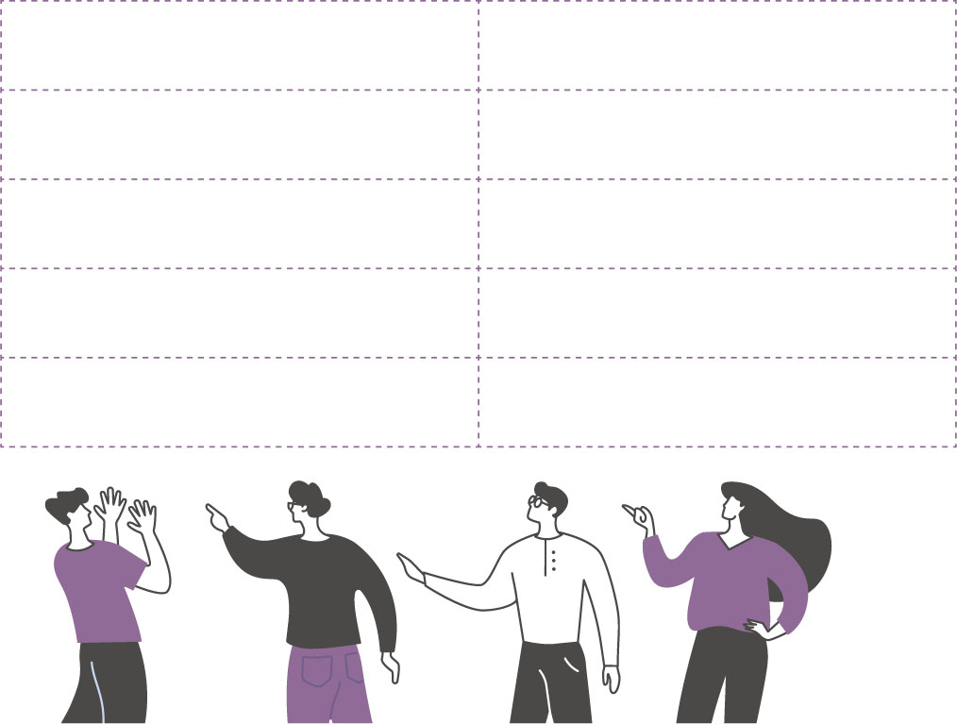

|  |  |
| --- | --- |
| 1. The monkey attacked the elephant. | 6. Many people visit the country every year. |
| 2. The car hit an old man. | 7. The cook will bake a cake tomorrow. |
| 3. The clerk gave the ice cream to the kid. | 8. The farmer has picked all the apples. |
| 4. The doctor is treating the lady. | 9. We should finish the report before Friday. |
| 5. The boy is mopping the floor now. | 10. You can buy fresh juice at that shop. |

|  |  |
| --- | --- |
| 1. The monkey attacked the elephant. | 6. Many people visit the country every year. |
| 2. The car hit an old man. | 7. The cook will bake a cake tomorrow. |
| 3. The clerk gave the ice cream to the kid. | 8. The farmer has picked all the apples. |
| 4. The doctor is treating the lady. | 9. We should finish the report before Friday. |
| 5. The boy is mopping the floor now. | 10. You can buy fresh juice at that shop. |