Wordsheet Week8 Class:______ Seat number:___ Name:__________
一、Scale introduction
Ex: 1:25,000 scale
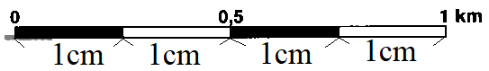
1、1 centimetre (cm) on map=25,000 cm on the ground.
2、 1cm on the map=250 metres (m) on the ground.
3、 4cm on the map= 1 kilometre (km) on the ground.
[DIY] Make a Transparent sheet as below

四、How to tell someone where you are by using coordination?
If you are injured and unable to move, how to apprize where you are ?
For example: The apprize coordinate is ( 018 , 856 )
