教育部國民及學前教育署補助國民中小學部分領域課程雙語教學實施計畫
本土雙語教育模式之建構與推廣：以臺灣國中小為現場之實踐

本土雙語教育模式之建構與推廣：以臺灣國中小為現場之實踐
雙語課程教案設計
The Design of Bilingual Lesson Plan
※以下表格採中文或英文填寫皆可，然鼓勵以英文填寫。The blanks can be filled in Chinese or English, but English is encouraged.
學校名稱  School |  |  | 中興國小  ZhongXing Elementary School |  | 課程名稱  Course | 健康  Health
單元名稱  Unit |  |  | 單元二：快樂每一天  Unit 2: Happy Every Day |  | 學科領域  Domain/ Subject | 健康與體育  Health and Sports
教材來源  Teaching Material |  |  | 翰林版四上健體課本  Hanlin Edition Grade 4 Physical Fitness Textbook |  | 教案設計者  Designer | 曾宗宇  Teacher Jeffrey
實施年級  Grade |  |  | 四年級  fourth grade |  | 本單元共 8 節  This unit has 8 sections in total
教學設計理念  Rationale for Instructional Design |  |  | 透過模仿學習，表現基本的自我調適技能。  Demonstrate basic self-adjustment skills through imitation learning.
學科核心素養  對應內容  Contents Corresponding to the Domain/Subject Core Competences |  |  | 總綱  General Guidelines | 健體-E-A1  具備良好身體活動與健康生活的習慣，以促進身心健全發展，並認識個人特質，發展運動與保健的潛能。  Physical Fitness - E-A1  Develop good physical activity and healthy living habits to promote healthy physical and mental development, recognize personal characteristics, and develop potential in sports and health.
 |  |  | 領綱  Domain/Subject Guidelines | 【健康與體育領域】  健體-E-A1  【英語領域】  英-E-A1 英-E-B1 英-E-C2  【Comprehensive field】  Fitness-E-A1  【English domain】  English-E-A1 English-E-B1 English-E-C2
 |  |  | 校本素養指標  School-based Competences | 運用基本的生活技能，因應不同的生活情境。  Apply basic life skills to cope with different life situations.
學科學習重點  Learning Focus |  |  | 學習表現  Learning Performance | 1b-II-1 認識健康技能和生活技能對健康維護的重要性。  1b-II-2 辨別生活情境中適用的健康技能和生活技能。  3b-II-2 能於引導下，表現基本的人際溝通互動技能。  1b-II-1 Recognize the importance of health skills and life skills for maintaining health.  1b-II-2 Identify applicable health skills and life skills in real-life situations.  3b-II-2 Demonstrate basic interpersonal communication and interaction skills under guidance.
 |  |  | 學習內容  Learning  Contents | Fb-II-3 情緒的類型與調適方法。  Fb-II-3 Types of emotions and ways to adjust them.
學生準備度  Students’ Readiness |  |  | 學科準備度 Readiness of Domain/Subject  能於引導下，表現基本的人際溝通互動技能。  Can demonstrate basic interpersonal communication and interaction skills under guidance.
英語準備度 Readiness of English
一.英文字彙
School anniversary(校慶), Sports meeting(運動會), Traits(特質), Interest (興趣), Communicate(溝通), Family(家人), Friend (朋友)
二.英文句型
What's being sold at this year's fair?
How many people are there in your family?
三.課室用語
Look at me, please.請看我/Try it!試試看/ Well done.做得很好Louder,please.音量 請大聲一點/ Excellent很棒
單元學習目標  Learning Objectives |  |  | 覺察個人的優勢能力，並能表達對周遭成員的關心與情感。  Be aware of your own strengths and abilities, and be able to express concern and affection for those around you.
中／英文  使用時機  Timing for Using Chinese/ English  ※請填寫清楚何時、何處使用中/英文。  Please describe in detail when and where you use Chinese/English. |  |  | 教師 Teacher |  |  | 學生 Students
 |  |  | When：  1.搭配課本在課程開始、進行中、及結束時，使用課室英文。  1.Use English with textbooks at the beginning, middle, and end of the course.  2.提問時使用英文。  2. Use English when asking questions.  Where：學習單  Where: Study sheet |  |  | When：  1.課程開始、進行中、及結束時，使用課室英文。  2.回答問題時使用英文。  Where：學習單  Where: Study sheet
教學方法  Teaching Methods |  |  | 情境教學法、講述法、討論教學法、分組合作學習法  Situational teaching method, narrative method, discussion teaching method, group cooperative learning method
教學策略  Teaching Strategies |  |  | 1.反覆口語與紙筆練習，使學生熟悉單字。  2.利用分組合作學習，讓學生相互精進與增能  3.以遊戲化教學方式融入課程，讓學生能浸濡在情境化英文中成長。  1. Repeat oral and paper-and-pencil exercises to make students familiar with words.  2. Use group cooperative learning to allow students to improve and empower each other  3. Integrate game-based teaching into the curriculum so that students can immerse themselves in contextualized English and grow.
教學資源及輔助器材  Teaching Resources and Aids |  |  | 資源：1. 自製投影片2. 教學光碟 3. Youtebe影片  器材：白板、學習單  Resources: 1. Self-made slides 2. Teaching CDs 3. Youtebe videos  Equipment: whiteboard, study sheets
評量方法  Assessment Methods |  |  | 實作評量、口頭評量、學習單、分組活動  Practical assessment, oral assessment, study sheets, group activities
評量規準  Rubrics |  |  | A(優秀) B(良好) C(基礎) D(不足) E(落後)  ＊能主動提出控制情緒的方法，並能演練避免情緒失控且與人溝通的方法。 ＊能探索控制情緒的方法，並能演練避免情緒失控且與人溝通的方法。 ＊能覺察 控制情緒的方法，並能演練避免情緒失控且與人溝通的方法。 ＊能參與控制情緒的方法，並能演練避免情緒失控且與人溝通的方法。 未達D級
議題融入  Issues Integrated |  |  | 生涯規劃教育  涯E4 認識自己的特質與興趣。  涯E6 覺察個人的優勢能力。  家庭教育  家E7表達對家庭成員的關心與情感。  Life Planning Education  Career E4: Recognize your own characteristics and interests.  Career E6: Identify your strengths and abilities.  Family Education  E7 expresses care and affection for family members.
教學流程 Teaching Procedures
※以下欄位若活動內容是需要使用英文進行，請以英文撰寫，並須依據前面的中/英文使用時機撰寫。Please use English to specify your teaching activities that are executed in English in the classroom based on the timing for using Chinese/English section.
第一節 | 【活動1：心情溫度計-趣味競賽我第一】  一、準備階段 Preparation stage  1.老師以我們班校慶「趣味競賽」得到三年級冠軍的照片為導引，及念課本對話框的內容。提問：「對於大隊接力賽這個事件，每個人有什麼不同的情緒反應？」（7’）  1. The teacher used the photo of our class winning the third grade championship in the school anniversary "Fun Competition" as a guide and read the content of the dialog box in the textbook. Question: "What are everyone's different emotional reactions to the relay race?"  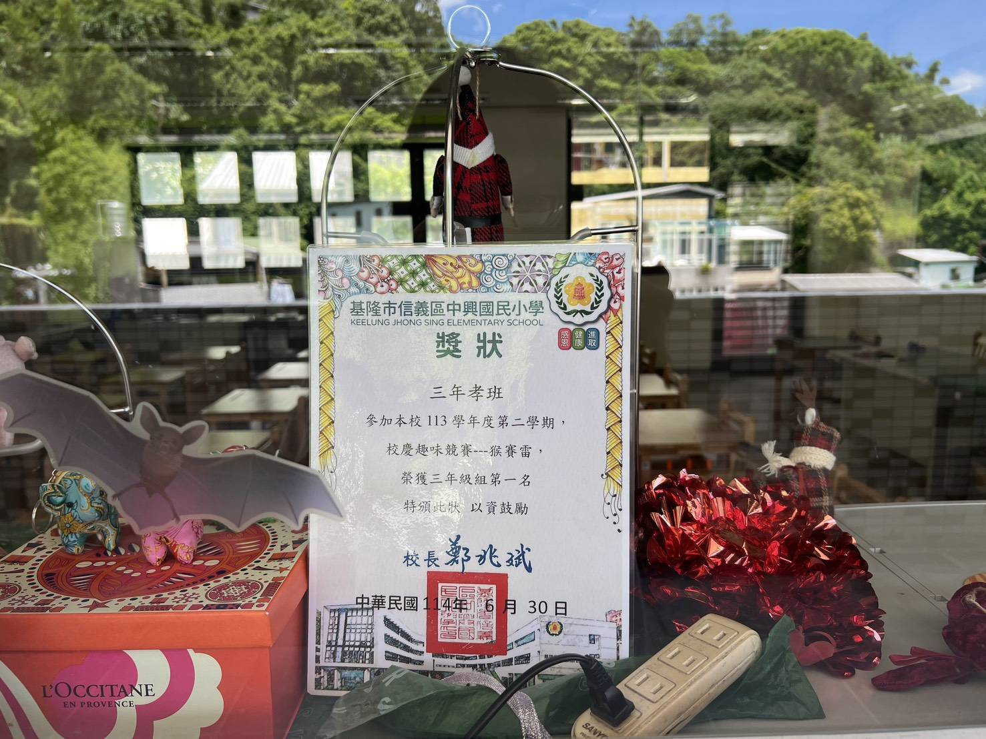  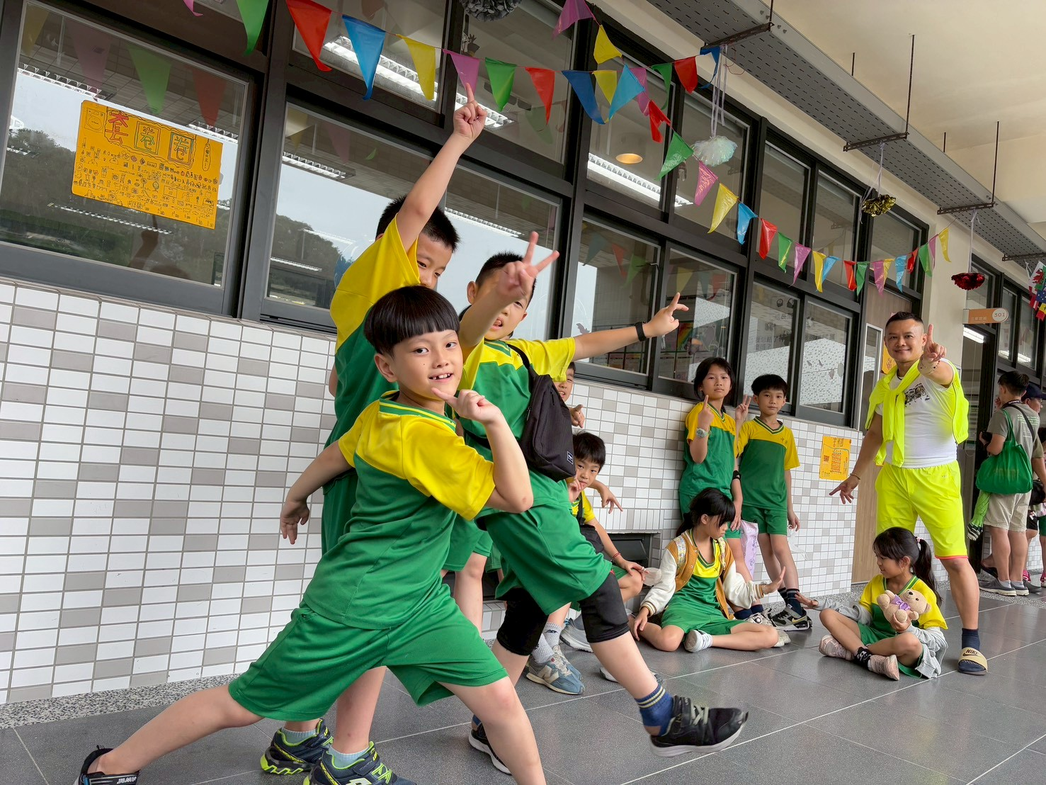  2. 介紹本學期雙語綜合課的上課方式（3’）  Teacher Jeffrey的雙語綜合課，老師用英語問時，孩子可用  英語或中文回答，老師用中文問時，你可以用英語或中文回答，用你想用  的語言，學期末，我們再綜合評量你的雙語能力。  3. 學生介紹自己，老師將問題及回答方式投影，引導學生逐題完成(7’)  二、發展階段 Development stage(18’)  1.老師請同學填寫情緒拼圖的學習活動，並畫出自己面對角色時可能的情緒反應。  2.教師請同學發表自己對角色情緒的辨識結果，並討論有何異同。  1. The teacher asks students to complete the emotional puzzle learning activity and draw their own possible emotional reactions when encountering the characters.  2. The teacher asks students to share their own identifications of the characters' emotions and discuss any similarities and differences.  三、總結階段 Summary stage(5’)  依照之前提問，利用Guess and Vote!請孩子們依自己的狀況發表中英夾雜的想  法並分享校園內外心情抒發的角落，並請孩子們加入自己的經驗進行分享，例如：你曾經和誰到過這裡？你什麼時候會想來這個地方？在這個地方時，你有什麼感覺？  Following the previous questions, use Guess and Vote! to ask children to express their thoughts in a mix of Chinese and English, and share where they expressed their feelings, both inside and outside the school. Invite them to include their own experiences, for example: Who have you been here with? When did you first want to visit this place? How did you feel when you were there?  第一節結束 End of the first session |  |  |  |  |  |  | 時間 Time
 |  |  |  |  |  |  |  | 40min
第二節 | 【活動2：心情調適萬花筒】  - 準備階段 Preparation stage（5’）  1.利用這次園遊會三年孝班「單日營業額全三年級第一」的「套圈圈」為例，老師抽籤請孩子演示「套圈圈」沒中時的「負面感受」。  2.老師請演示的同學分別分享演戲時的內心感受。  3.教師請孩子討論：在負面情緒當下時，哪些人的回應能夠幫助你？  1. Using the "ring toss" activity, which was the highest single-day sales activity among all third-grade students at the garden party, as an example, the teacher draws lots and asks the children to demonstrate the negative feelings they experience when they miss the ring toss.  2. The teacher asks the students who are demonstrating to share their inner feelings during the performance.  3. The teacher invites the children to discuss: When faced with negative emotions, whose responses can help you?  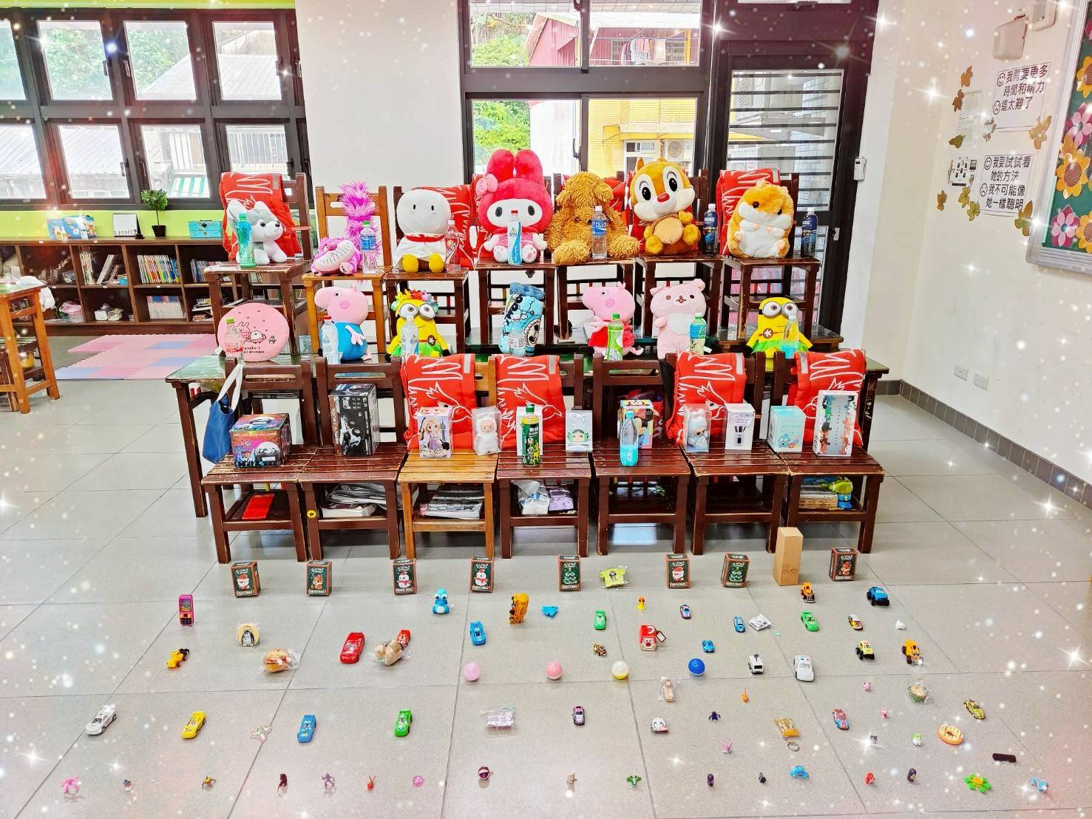  - 發展階段 Development stage（25’）  1.老師請同學完成課本活動並討論：面對失誤的正向或負向情緒對後面的行動會產生什麼影響？  2.教師請同學寫出對自己的鼓勵話語，並大聲唸出來。  3.老師提問：聽到這些正向語言的感受如何？  1. The teacher asks students to complete the activity in the textbook and discuss: How do positive or negative emotions in response to a mistake affect subsequent actions?  2. The teacher asks students to write down encouraging words for themselves and read them aloud.  3. The teacher asks: How do you feel when you hear these positive words?  - 總結階段 Summary stage（10’）  將今天的學習成果，在聯絡簿上延伸家長將這些教材帶入家庭生活，以「控制情緒我第一」與「擺脫負面我最行」為主題，與孩子一同學習。不僅能有效鞏固學習成果，更能將情緒管理化為優質、有趣的親子互動時光。  Extend today's learning results in the communication book. Parents should incorporate these teaching materials into their family life, learning with their children on the themes of "Controlling Emotions First" and "I'm the Best at Getting Rid of Negativity." This will not only effectively consolidate learning outcomes but also turn emotional management into high-quality, enjoyable parent-child interaction.  第二節結束 End of the first session |  |  |  |  |  |  | 40min
第三節 | 【活動3：健康EQ面面觀】  - 準備階段 Preparation stage（10’）  1.老師請同學朗讀課本中「郭婞淳」的故事，並播放關於郭婞淳生平的相關影片及英文資料。  2.教師帶領同學討論課本內頁的問題，並說明郭婞淳值得學習之處，在於她沒有因為「獨特性」而放棄努力，反而在與別人不同的道路上開展人生，提升自我價值，並找到自己的舞臺。  1. The teacher asks students to read aloud the story of Kuo Hsing-chun from the textbook and plays a video and English materials about Kuo's life.  2. The teacher leads a discussion of the questions on the textbook pages, explaining that Kuo's worthy role is that she did not give up on her uniqueness. Instead, she pursued a different path in life, enhanced her self-worth, and found her own stage.  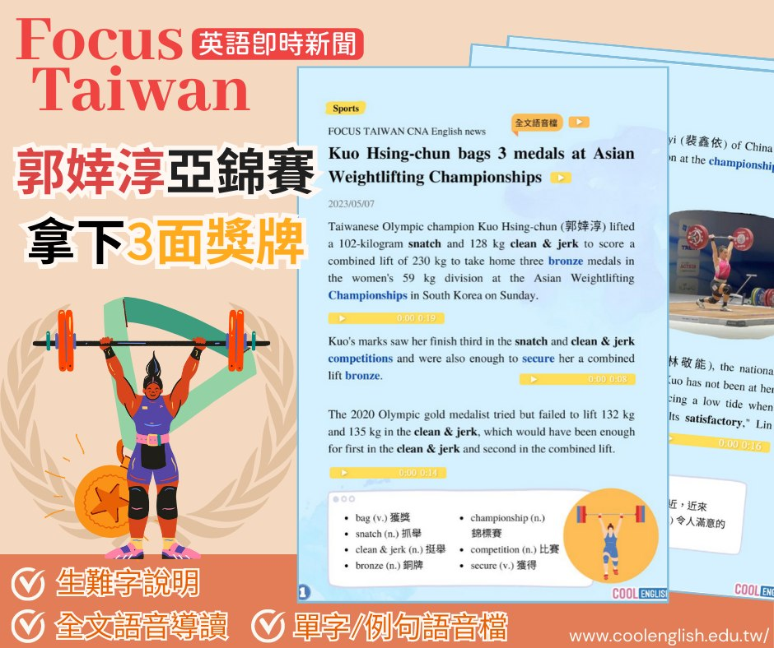  發展階段 Development stage（25’）  1.老師說明課本負面情緒的調適方法的步驟。  2.老師請孩子發表「想一想」的答案。  3.孩子發表自己曾經克服低潮的經驗。  4.老師提問：除了課本的方法，還有哪些方式可以調適負面情緒？  5.老師將步驟字卡張貼在黑板上，請同學按照課本方法思考如何運用在自己的困境上。  6.老師準備一個紙盒和一疊便條紙，請同學將自己希望克服的障礙寫在紙條上，投入紙盒內，老師隨機抽取紙條念出問題，請同學分享解決方法。  1. The teacher explains the steps for managing negative emotions from the textbook.  2. The teacher asks the children to share their answers to the "Think About It" question.  3. The children share their experiences overcoming a low point.  4. The teacher asks: Besides the methods in the textbook, what other ways can be used to manage negative emotions?  5. The teacher posts flashcards with the steps on the blackboard and asks the students to think about how to apply the textbook methods to their own difficulties.  6. The teacher prepares a cardboard box and a stack of notepaper. Students are asked to write down the obstacle they hope to overcome on a slip of paper and place it in the box. The teacher randomly draws a slip of paper, reads the problem, and invites students to share their solutions.  三、總結階段 Summary stage（5’）  老師提問：「經過這個活動的學習，你學到了哪些事情？」  1.每個人都是獨一無二的個體。  2.尊重別人，就是尊重自己。  3.人人要時常掃除自己心中的負面情緒，並要跟別人分享與求助。  4.幫助別人克服負面情緒，就是尊重與體現自己的情緒。  5.良好的EQ，方能有良好的身心靈。  The teacher asked, "What have you learned from this activity?"  1. Everyone is unique.  2. Respecting others is respecting yourself.  3. Everyone should constantly clear away negative emotions and share and seek help from others.  4. Helping others overcome negative emotions is respecting and embracing your own emotions.  5. A healthy EQ is essential for a healthy mind, body, and spirit.  have you learned from this activity?"  第三節結束 End of the first session |  |  |  |  |  |  | 40min
第四節 |  | 【活動4：跟夢想Say Yes】  一、準備階段 Preparation stage(17’)  1.利用英文自我介紹學習單，書寫英文自我介紹並在背後畫出自己。  2.老師分享：「和別人不同」會使我們在班級中感到不安，可是隨著年齡增長會接觸更多不同類別的人，慢慢會理解「和別人不同」才是常態。不要害怕獨特性，因為獨特性才能使你成為獨一無二的自己。  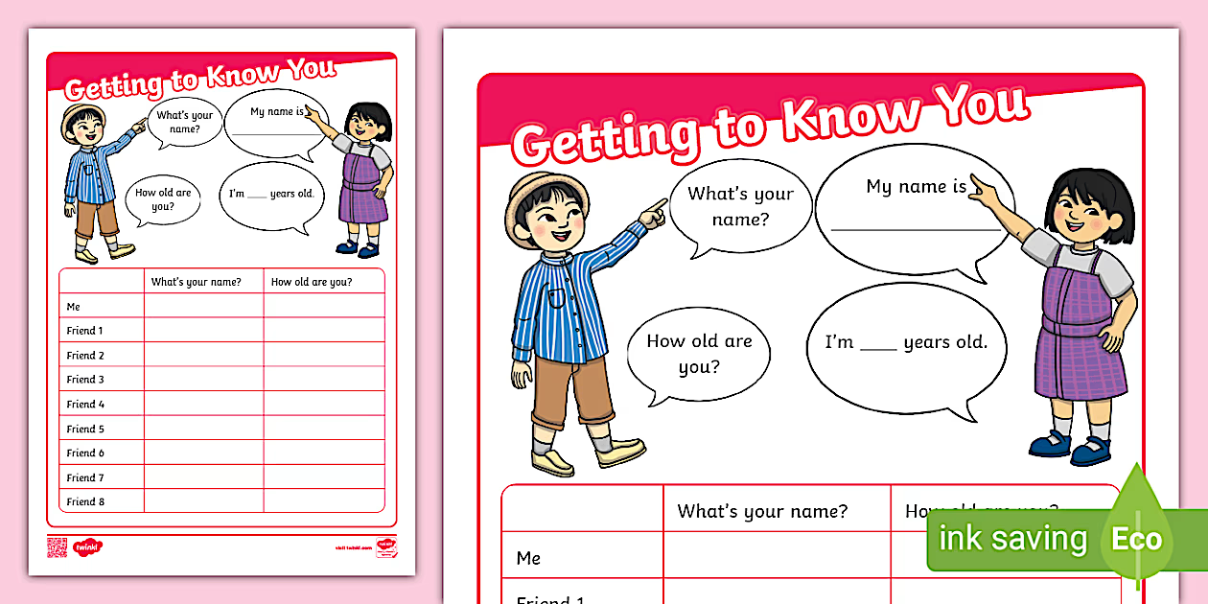  1. Use the English Self-Introduction Worksheet to write a self-introduction in English and draw yourself on the back.  2. The teacher shared: "Being different from others can make us feel uneasy in class, but as we grow older and interact with more diverse groups of people, we gradually understand that being different is normal. Don't be afraid of uniqueness, because uniqueness is what makes you unique."  二、發展階段 Development stage(18’)  1.孩子上臺發表「二十年後的我」自畫像與英文自我介紹。  2.老師說明：理想的「二十年後的自己」也許很難想像，需要不斷地透過認識自己及探索周遭的環境去創造，就像同一個主題，每個人畫出來的都不同，但完成後大家可以看到彼此的作品。  1. Children take the stage to present a self-portrait of "Me in 20 Years" and a self-introduction in English.  2. Teacher's explanation: The ideal "me in 20 years" may be difficult to imagine. It requires continuous self-understanding and exploration of the environment. Just like the same theme, each person's drawing may be different, but once completed, everyone can see each other's work.  三、總結階段 Summary stage(5’)  1.完成課本中的「夢想地圖」。  2.下次彼此分享自己的夢想地圖。  3.老師說明：理想中的自己和現在的自己中間所留的空白，就是我們所要努力完成的  拼圖，我們必須知道這塊拼圖是什麼，也許是知識、技能、學歷、金錢⋯⋯，找到拼圖  並且放置在自己的地圖上，才能一步步看到未來自己的完整樣貌喔。  1. Complete the "Dream Map" in the textbook.  2. Share your dream maps with each other next time.  3. Teacher's explanation: The gap between your ideal self and your current self is the puzzle piece we must strive to complete. We must know what that piece is—perhaps knowledge, skills, education, money... Find the puzzle piece and place it on your map. Only then can you gradually see the complete picture of your future self.  第四節課結束 The end of the fourth class |  |  |  |  | 40min
第五節&第六節 |  | 【活動5：「家人與我」慶團圓】  - 準備階段 Preparation stage (15’)  從「家人與我」照片，討論以下課題與內容，分組進行閱讀、討論並上臺報告：  1.老師提問：有沒有去過同學的家裡？同學的家和自己的家有什麼不同？你比較喜歡哪個家？  2.老師提問：家和房屋有什麼不同？溫暖的家需要具備什麼？  3.老師總結：家和房屋最大的不同就是：家有人與人之間的情感連結。我的家人是專屬於我的，所以我的家也是獨一無二的存在。  The students read and discussed the book "Bully Terminator Jack Dray" and collected content from the "Child and Youth Welfare and Rights Protection Act", "Domestic Violence Prevention and Control Act", "Convention on the Rights of the Child" and other documents in groups and gave reports on stage.  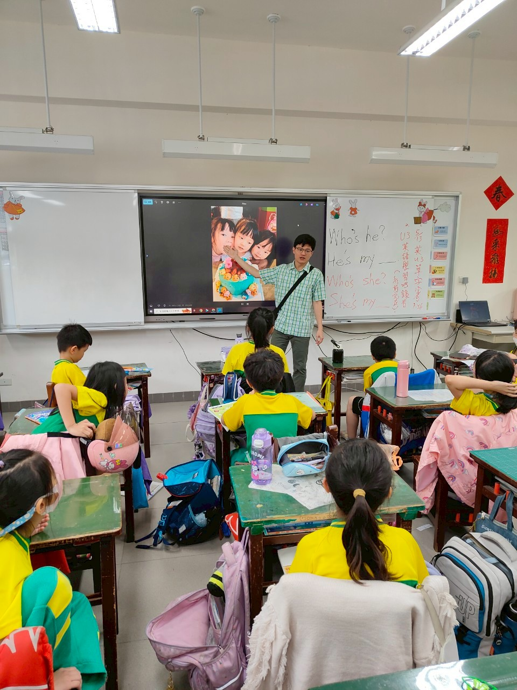  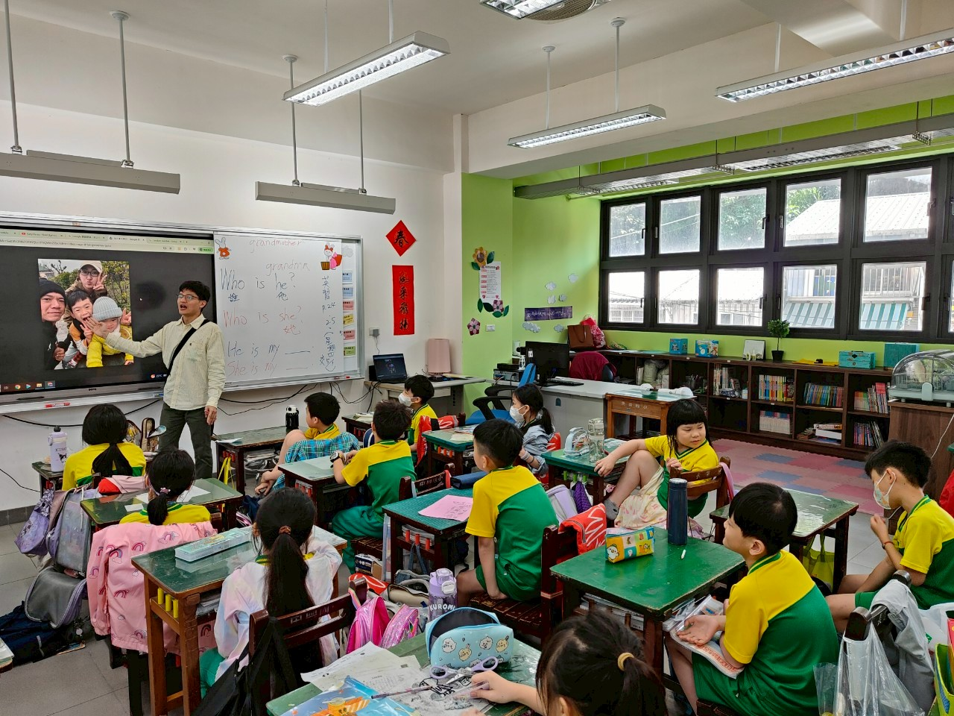  二、發展階段 Development stage (50’)  1.老師請同學拿一張白紙，配合「家人與我」照片寫下：  (1).自己的家人及家人為我做的付出。  (2).我對家人的付出是什麼？  2.老師提問：家人為你付出了什麼？沒有這些付出會有什麼影響？請孩子們分享。  3.老師說明並總結：家庭的功能包含了經濟（食衣住行）、情感、安全、教育等，家人提供了這些功能，才能滿足我們的各種需求。  我們也許會羨慕別人家庭的物質生活或家人之間的感情，但那永遠不可能屬於我，只有和家人共同努力營造自己理想的家庭生活，才能擁有家的歸屬感。  1. The teacher asks students to take a piece of white paper and write down the following with the photo of "My Family and Me":  (1) My family and what they have done for me.  (2) What have I done for my family?  2. The teacher asks: What have your family done for you? What would happen if you didn't do that? Ask the children to share.  3. The teacher explains and summarizes: The functions of a family include economy (food, clothing, housing, transportation), emotions, security, education, etc. The family provides these functions to meet our various needs.  We may envy the material life of other families or the affection between family members, but that will never belong to me. Only by working together with our family to create our own ideal family life can we have a sense of belonging to home.  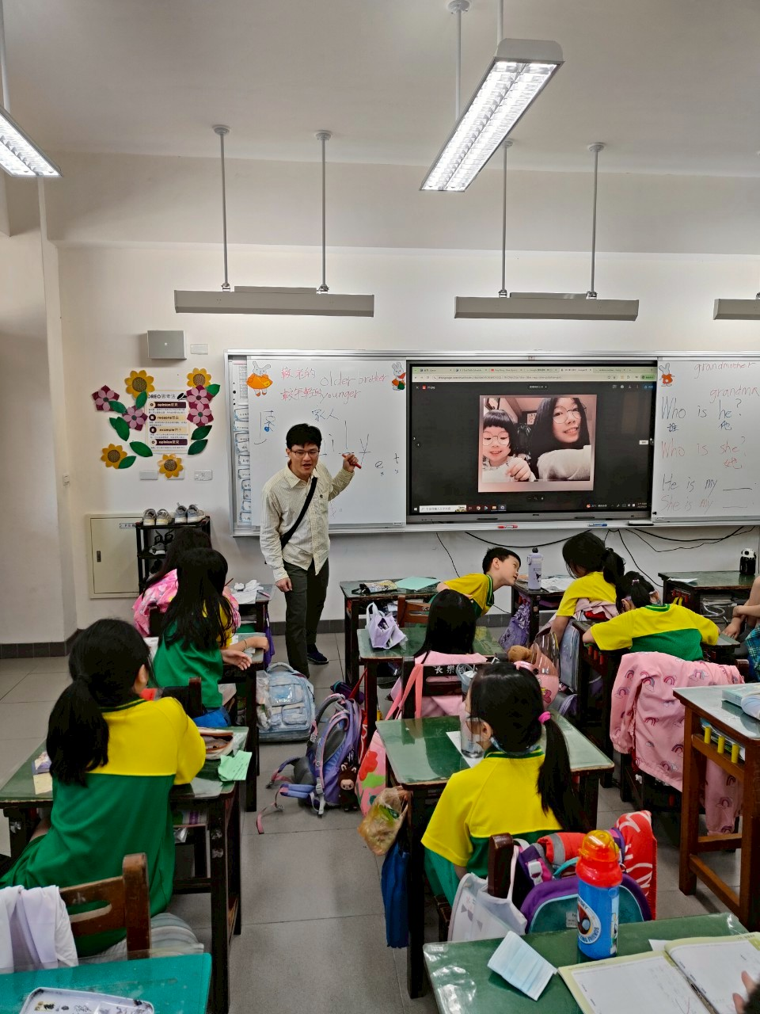  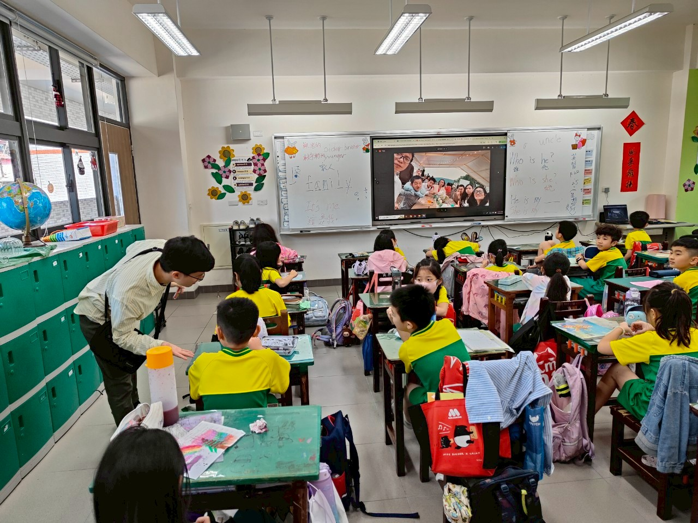  三、總結階段 Summary stage(15’)  1.老師請孩子自評「我的愛家行動」。  2.老師請同學發表自己平時對家人表達愛的方式以及家人的回應。  3.老師總結：家人的互動關係需要長期的經營，願意用正向的態度與行動彼此支持，家庭才能真正成為家人的避風港。  1. The teacher asks the children to self-evaluate their "My Love for Family" activities.  2. The teacher asks the students to share how they typically express love to their families and how their families respond.  3. The teacher concludes: Family relationships require long-term cultivation. Only when families are willing to support each other through positive attitudes and actions can they truly become a safe haven.  第五、六節課結束 End of the fifth and sixth classes |  |  |  |  | 80min
第七節&第八節 |  | 【活動六、快樂的每一天-探究與實作成果分享會】  一、準備階段 Preparation stage (15’)  1.以【認識情緒】六種基本情緒以及五種紓解方法  (https://www.youtube.com/watch?v=0b-NnFKB6v8)  及《心靈環保兒童生活教育動畫5》21 溝通的遊戲(國語版) (https://www.youtube.com/watch?v=FzOk7MAU_Mo)  、Learn About Emotions and Feelings | Social Skills For Kids | Learning Videos | Kids Videos | EMoMee  (https://www.youtube.com/watch?v=1oOo3npOcZk)  ─動畫為成果分享會之導引。  1. Using "Understanding Emotions": Six Basic Emotions and Five Relief Methods  and "Spiritual Environmentalism Children's Life Education Animation 5" 21 Communication Games (Mandarin Version)  --the animation served as a guide for the results sharing session.  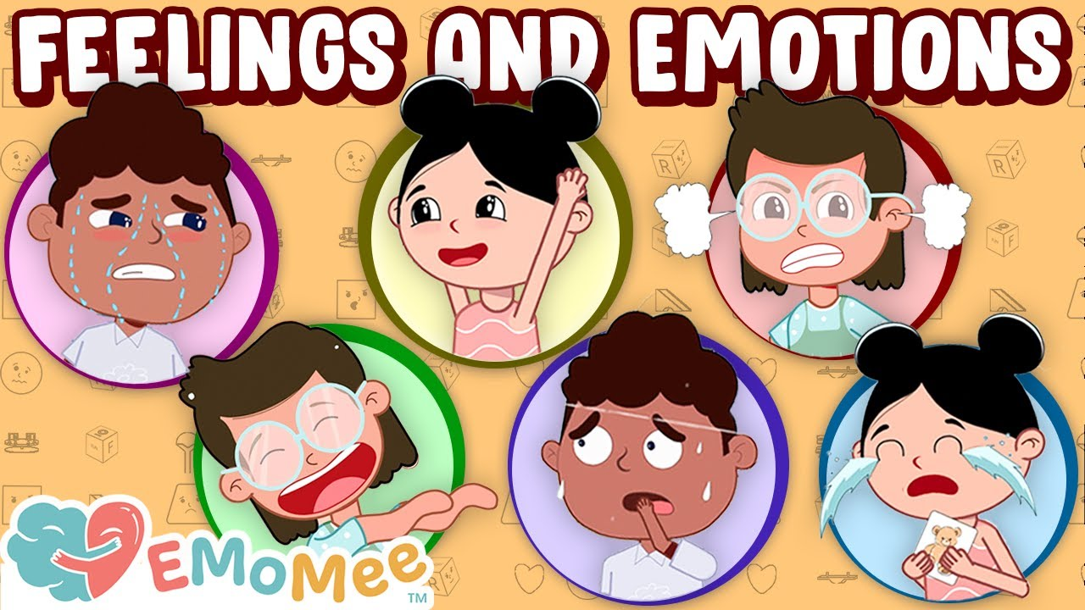  二、發展活動 (Team Discussion) (50’)  1.討論成果發表會進行的方式。  (1)透過海報呈現。  (2)場地如何布置。  2.討論成果發表時，引導孩子思考要介紹的重點是什麼？  (1)「情緒管理/與人溝通/排解負面/尊重獨特」改造工作前後的景象。  (2)「情緒管理/與人溝通/排解負面/尊重獨特」改造工作過程的介紹。  (3)對於「情緒管理/與人溝通/排解負面/尊重獨特」改造工作的想法。  (4)經過改造行動後，這個世界變快樂的部分，以及對這個世界的感覺。  3.成果發表會  (1)發表並展示成果，鼓勵孩子說說進行改造時遇到的困難，解決的方式、過程與結果。  (2)鼓勵孩子專心聆聽並給予回饋。  4.省思與發表  (1)對於改造的過程，你印象最深刻的事情是什麼？  (2)如果重新再來一次，對於改造的行動，你會再做什麼調整嗎？為什麼？  1. Discuss how to conduct the results presentation.  (1) Present through posters.  (2) How to arrange the venue.  2. When discussing the results presentation, guide the children to think about the key points to be presented.  (1) The scene before and after the “emotional management/communication with others/resolving negativity/respecting uniqueness” transformation work.  (2) Introduction to the “emotional management/communication with others/resolving negativity/respecting uniqueness” transformation work process.  (3) Thoughts on the “emotional management/communication with others/resolving negativity/respecting uniqueness” transformation work.  (4) The parts of the world that have become happier after the transformation actions, and how they feel about the world.  3. Results Presentation  (1) Present and display the results. Encourage the child to talk about the difficulties encountered during the transformation, how they solved them, the process, and the results.  (2) Encourage the child to listen attentively and give feedback.  4. Reflection and Presentation  (1) What impressed you most about the transformation process?  (2) If you could do it again, would you make any adjustments to your transformation actions? Why?  三、總結階段 Summary stage(15’)  1.老師請孩子依照課本的生活情境畫出自己實際生活的感受的「我的心情日記」，並分享討論。  2.老師說明：同樣的生活情境帶給人不同的生活感受，往往是因為人對於自己的生活所抱持的態度與想法不同，所採取的應對行動也會不同，當我們用樂觀的態度及積極的行動去面對每一天的生活時，人生就會朝向你所夢想的樣子去發展，千萬不能小看信念的力量！  1. The teacher asks the children to draw a "My Mood Diary" based on the life scenarios in the textbook, sharing their own feelings about life and discussing them.  2. The teacher explains: The same life situation can bring different experiences to people, often because people have different attitudes and perspectives about their lives, and therefore take different responses. When we face each day with an optimistic attitude and positive actions, our lives will develop into the life we dream of. Never underestimate the power of faith!  第七、八節結束End of the seventh and eighth quarters  ～～ |  |  |  |  | 80min
參考資料  References |  |  | 影音資料：【認識情緒】六種基本情緒以及五種紓解方法  (https://www.youtube.com/watch?v=0b-NnFKB6v8)  《心靈環保兒童生活教育動畫5》21 溝通的遊戲(國語版)  (https://www.youtube.com/watch?v=FzOk7MAU_Mo)  書面資料：˙學會不反應：屏蔽那些不重要的事，過不內耗的人生  （2025）。富書。春天出版社。  ˙我不喜歡你這樣對我！（2011）。Steven Kroll。大穎文化。  ˙不要就是不要：兒童自我保護繪本（2017）。Jayneen Sanders。小魯文化。  ˙不是我的錯（2019）。雷．克里斯強森。和英出版社。

※期待雙語教師能逐年使用更多英文撰寫本教案。We are looking forward that you can use more and more English to write this lesson plan year by year.

